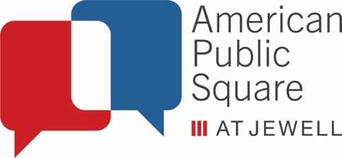

American Public Square
Internship Program Outline

The American Public Square Student Intern program is designed to give college level students an opportunity to develop professional skills while working towards their degree. If students wish to apply these internships towards their course degree requirements they should talk to their professors to ensure this is possible. Students will work in partnership with American Public Square at Jewell in one of three capacities:

Program Intern: The APS Program Intern will work directly with the Program Coordinator to assist in developing our primary American Public Square programming. The Program Intern will help to develop APS primary and secondary events, work on membership outreach and promotion, work alongside committees to determine the direction and content of programs and assist with events on the day of.

Communications Intern: The APS Communications Intern will work directly with the Executive Director to assist in community outreach, marketing, social media, and brand development for American Public Square. The Communication intern will be responsible for updating and maintain American Public Square’s social media presence (Facebook, Instagram, Twitter, ect.), working to develop newsletters and media outreach to the community, and working on brand development for the organization.

KC Common Good Intern: The goal of the KC Common Good Internship is to assist with the Community Resources Portal. The Community Resources Portal will highlight the organizations that are working to address the root causes of violence throughout the Metro, detail the ways in which their organizations can help, how people can access their services, et al. The database will include general information, access to job openings, listings about skills training opportunities, a community calendar, and the like. Additionally, the platform will track specific metrics such as visits to the site, volume of resources available, and other opportunities posted/filled, et al. We are building the necessary functionality and have engaged community leaders to help establish the minimum specifications.

Internship Timeline: These internships progress on a 12-week cycle, aligning with the typical college semester (Spring & Fall). Each internship is divided into 12 10-hour work weeks throughout the semester. Internships are not limited to one semester, and interns may re-apply for an additional semester if they choose. Spring Internship will commence from approximately January-May, Fall Internship will commence from approximately August-December. APS will work to arrange a schedule that works for all interns.

Student Committee: All interns will take part on an APS Student Committee which will be responsible for designing and executing a student-oriented APS style program. Interns will report to the APS Student Coordinator staff and will be expected to spend a portion of their time on this project.

Application Instructions

To apply for this position, please send a copy of your current resume along with a cover letter stating why you are interested in the position and what your post-graduation career goals are to adam@americanpublicsquare.org

While Applications can be submitted year-round, the two main periods of internship are Spring Semester (January-May) and Fall Semester (August-December).

Spring Semester Deadlines
- September/October: Receiving and Reviewing Applications
- November: Applicants contacted for phone or in-person interviews
- December: Final Decisions Made
- January-May: Internship Period

Fall Semester Deadlines
- April/May: Receiving and Reviewing Applications
- June: Applicants contacted for phone or in-person interviews
- July: Final Decisions Made
- August-December: Internship Period

If you have any additional questions about these internship positions please contact the APS Program Coordinator Adam Erickson at Adam@Americanpublicsquare.org

