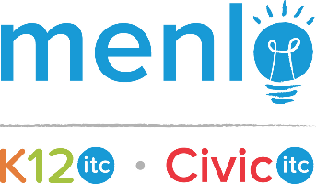
Desktop Support Technician
Kansas City, MO
Description
If you’re looking to work in a start-up technology environment with high amounts of collaboration and the opportunity to contribute in a fast growing team, look no further than Menlo!

The Desktop Support Technician will provide a very high level of customer service to our clients. They will consistently and accurately document and prioritize user technology issues and attempt to resolve on initial contact. The technician will troubleshoot problems, advise on the appropriate action and respond to user requests via phone and electronic submission.

RESPONSIBILITIES
- Provide technical support for users via telephone, chat, and web tickets in a professional and courteous manner
- Effectively diagnose and troubleshoot malfunction of computer or network devices relating to user error, faulty hardware, or software/server/network issues
- Analyze service request data for trends and recommend process improvements for ticketing system
- Document all pertinent user identification information, including name, department, contact information, nature of problem or issue, computer name, resolution, etc.
- Use documentation, peers, and any other resources to resolve issue on initial contact
- Build rapport and elicit problem details from customers
- Prioritize and escalate problems as appropriate
- Actively monitor and report compliance with the customer service level agreements
- All other duties as assigned
Requirements
KNOWLEDGE & EXPERIENCE
- Exceptional interpersonal skills, with a focus on rapport-building, listening, and questioning skills
- Understanding of various operating systems including Windows XP/7/8/10 and Mac OS
- Strong troubleshooting, software, and documentation skills
- Excellent knowledge of desktops, laptops, mobile devices, and other common peripheral devices
- Knowledge of basic computer hardware
FORMAL EDUCATION & PREFERRED CERTIFICATIONS
- High School diploma or equivalent
- Preferred MCP or entry-level technical certification
PERSONAL ATTRIBUTES
- Ability to absorb and retain information quickly with a high attention to detail
- Highly self-motivated with excellent customer service skills
- Experience working in a team-oriented environment
WORK CONDITIONS
- Sitting for extended periods of time
- Dexterity of hands and fingers to operate a computer keyboard, mouse, power tools, and to handle other computer components

