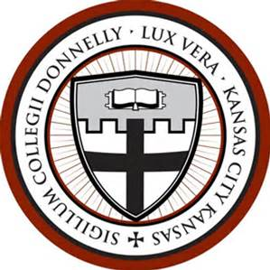
SATISFACTORY ACADEMIC PROGRESS

Reviewed/Updated Date: September 14, 2021
Approved by: Administrative Council
Responsible Official: Director of Financial Aid

Original Policy Statement

Satisfactory Academic Progress (Item Number 2)

The student may receive aid for a maximum of ninety-six (96) credit hours. The total number of hours may include up to thirty (30) hours of remedial or developmental coursework. (Associate Degree or Certificate Programs)

Proposed Policy Statement: (Adding undeclared students to the associate degree program requirements)

The student may receive aid for a maximum of ninety-six (96) credit hours. The total number of hours may include up to thirty (30) hours of remedial or developmental coursework. (Associate Degree, certificate programs, or Undeclared Programs)

