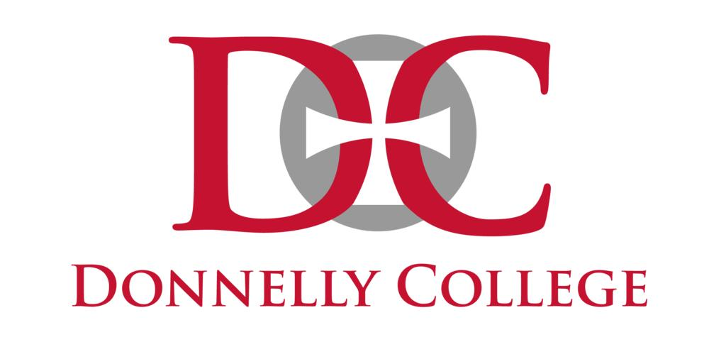

EN111 SF – Composition I
Term
Day/Time
Room
3 credit hours

INSTRUCTOR INFORMATION:
Name:
Office:
Office hours:
Telephone:
E-mail address:

COURSE DESCRIPTION:
This course is a co-requisite course, in conjunction with CCS099. This course develops skills in writing the major types of composition such as description, narration, example, analysis, definition, classification, comparison/contrast and cause/effect. Students will practice techniques needed in writing reports and learn basic library skills used in research.
More specifically, this class attempts to acknowledge and explain “academic writing” by offering a methodical and clear approach to meeting some of the challenges accompanying it. The premise is twofold: there is the assumption that academic writing is a challenging intellectual undertaking, albeit one that is essential to college admission and success; there is also the idea that academic thinking, reading, and writing are entwined with civic and life issues beyond the college years.
PREREQUISITES:
Accuplacer score of 227-240 or completion of Success First Reading & Writing with a C average.

REQUIRED TEXTBOOK & SUPPLIES:
From Inquiry to Academic Writing: A Text and Reader, 5th Ed., by Stuart Greene and April Lidinsky – ebook and/or printed textbook
Bedford Handbook, 10th ed. or other recent edition (2015-present)
Donnelly College Academic Planner (current year)
Collegiate Dictionary (Webster’s or Oxford recommended)
Collegiate Thesaurus (Roget’s recommended)
One 2” Three-ring binder with Five Tab Dividers; Lined, loose-leaf paper
Several black pens
Pencils (mechanical or No. 2)
Highlighters for peer editing (optional)
Sheet protectors

PHILOSOPHY OF GENERAL EDUCATION:
Donnelly College has consistently maintained a strong commitment to the liberal arts and sciences as a foundation for a complete education. The faculty strongly believes that the liberal arts and sciences provide the context through which students can engage with the larger questions about students’ place in the world and their pursuit of truth. Therefore, the College’s general education requirements are designed to ensure that liberal arts and sciences graduates develop a breadth of content knowledge and the skills and abilities which will enable them to become educated participants in a diverse global community.

DONNELLY COLLEGE LEARNING OUTCOMES:

- Communication Skills: Students will communicate effectively in writing and speaking.
- Technology and Information Literacy Skills: Students will demonstrate proficiency in information literacy skills.
- Symbolic Problem Solving: Students will demonstrate competency in qualitative and quantitative problem solving.
- Analytical Thinking: Students will employ reflective thinking to evaluate diverse ideas in the search for truth.
- Personal and Interpersonal Skills: Students will develop an understanding across cultural differences locally, nationally, and internationally.
- Academic Inquiry: Students will engage independently and effectively in lifelong learning.
- Values: Students will demonstrate moral and ethical behavior in keeping with our Catholic identity.

LIBERAL ARTS AND SCIENCES PROGRAM LEARNING OUTCOMES:
Upon successful completion of the Associate of Arts in Liberal Arts degree, the graduate should be able to demonstrate:
1. Proficiency and creativity in written and verbal communication.
2. Effective use of current technology in support of academic work.
3. Proficient use of qualitative and quantitative methods in problem solving.
4. Critical and Analytic thinking across a range of disciplines.
5. A commitment to ethics and integrity in academic and professional relationships, within the community and the environment.
6a. The ability to conduct research using sources, strategies, and approaches across disciplines. (AA)
6b. Use of the scientific method. (AS)
EN 111: ENGLISH COMPOSITION I STUDENT LEARNING OUTCOMES
Upon completion of EN 111, students will have the ability to
- Compose essays in a variety of styles, using thesis statements and evidence.
- Discover and evaluate information from a variety of sources, and then apply those sources to the student’s original written work.
- Engage multiple perspectives on a single topic.
- Compose papers free from plagiarism, using proper in text citation and works cited formatting.

Donnelly College Learning Outcomes | Associate of Arts Program Learning Outcomes | Student Learning Outcomes for EN 111: English Composition I | Application and Assessment
1. Students will communicate effectively in writing and speaking. | 1. Students will demonstrate proficiency and creativity in written and verbal communication. | 1. Students will have the ability to compose essays in a variety of styles, using thesis statements and evidence. | Passing average on all formal essays (scored using Donnelly College Writing Rubric; see attached).
2. Students will demonstrate proficiency in information literacy skills. | 2. Students will demonstrate effective use of current technology in support of academic work.
3. Students will demonstrate competency in qualitative and quantitative problem solving. | 3. Students will demonstrate proficient use of qualitative and quantitative methods in problem solving. | 4. Students will have the ability to compose papers free from plagiarism, using proper in text citation and works cited formatting. | Passing average on Long Annotated Bibliography (scored using Donnelly College Writing Rubric; see attached).
4. Students will employ reflective thinking to evaluate diverse ideas in the search for truth. | 4. Students will demonstrate critical and Analytic thinking across a range of disciplines. | 3. Students will have the ability to engage multiple perspectives on a single topic | Passing Scores on Literary Analysis (Common Read) using Donnelly College Writing Rubric, attached.
5. Students will develop an understanding across cultural differences locally, nationally, and internationally. | 5. Students will demonstrate a commitment to ethics and integrity in academic and professional relationships, within the community and the environment.
6. Students will engage independently and effectively in lifelong learning. | 6a. Students will demonstrate the ability to conduct research using sources, strategies, and approaches across disciplines.
7. Students will demonstrate moral and ethical behavior in keeping with our Catholic identity. | 5 (repeated). Students will demonstrate a commitment to ethics and integrity in academic and professional relationships, within the community and the environment.

This semester, Student Learning Outcomes #1 and #4 will be assessed in EN 111.

COURSE REQUIREMENTS and GRADING POLICY:
Assignments | Points
Participation (includes in-class work, preparation, workshops, discussions, etc.) | 300
Long Essays (3 at 100 points each) | 300
Short Essays (2 at 75 points each) | 150
Reflections (6 at 50 points each) | 300
Conferences (2 at 25 points each) | 50
Reading quizzes (10 points each) | 100
Total Possible Points | 1200

MISSED WORK: The assignment schedule I have set needs to be followed and I cannot accept assignments handed in late. Likewise, tests must be taken on the day they are given. There will be no makeup opportunities.

CANVAS: All course materials, grades, and communication with the instructor will be conducted in the Canvas online learning platform. Students are expected to check their accounts on a regular basis (i.e., 2X a week minimum).
Note: All communications regarding this course will be made via your Donnelly College email account. If you have questions about using Canvas, check the Online Student Guide available at https://community.canvaslms.com/docs/DOC-10701-canvas-student-guide-table-of-contents For any technical problems, call the assistance line at 1-855-593-5537. This line is available 24/7.

GRADING SCALE:
Grades will be assigned according to the following scale.
A: 90%-100% 1080-1200 points
B: 80%-89% 960-1079 points
C: 70%-79% 840-959 points
D: 60%-69% 720-839 points
F: Below 60% 719 or fewer points

DONNELLY COLLEGE WRITING RUBRIC:
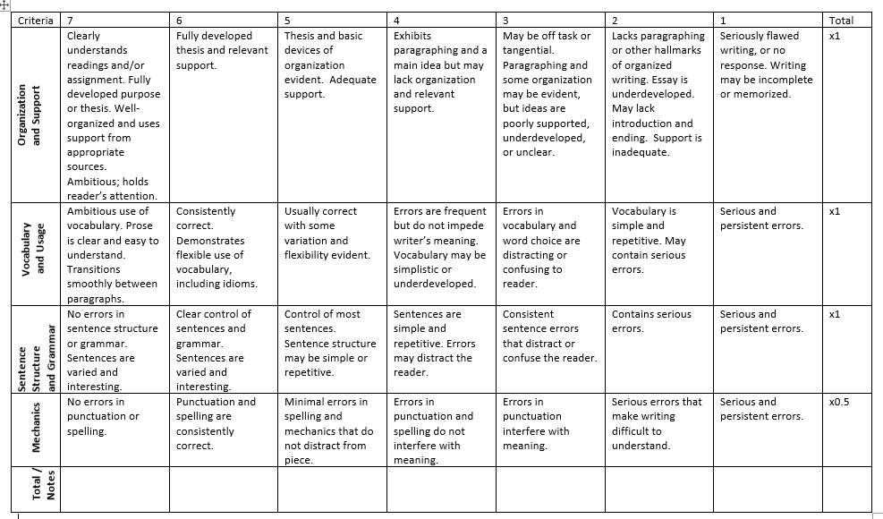

TUTORING REQUIREMENT: In order to earn an “A” grade on any Short Essay or Long Essay in this course, you are required to attend at least one revision session at Tutoring Center. Revising with a writing tutor does not guarantee an “A” grade, but an “A” cannot be earned unless you turn in a completed and signed yellow Tutoring receipt with the paper when it is due.
- Note that walk-in sessions are NOT guaranteed – it is your responsibility to find out this semester’s policies, including how far in advance you need to make appointments and whether there is a time requirement for those appointments.
- The Tutoring Center IS NOT AN EDITING SERVICE. You must go with a clear idea of what you need help with – with goals and specific requests in mind. You will not go expecting the tutor to “fix” your paper, nor will you ask them to proofread your work. That is not their job.
- You may find that there are particular tutors with whom you work well, and perhaps even tutors you prefer not to work with. That is absolutely fine – all the more reason to schedule your sessions well in advance of the paper’s due date – to ensure that you can work with the tutor you prefer.
- If you have questions about the ACE requirement or how tutoring works, ask Gretchen or stop by the Tutoring Center for more information.

EXPLANATION OF ASSIGNMENTS:

- Participation, Writing Team Work and Attendance: Students are expected to participate in class discussions, give constructive and thorough feedback in writing workshops and respond to reading assignments through questions and thoughtful response. See Attendance Policy below.
- Long Essays: Instructions will be provided for each of these. Please note that essays must be TYPED, using MLA formatting. Essays will have a length requirement. Essays are due on their due date at the BEGINNING of class. Late essays are not accepted in this course.
- Short Essays: These are shorter response-style essays that may help you in writing the longer essays.
- Reflections: Very short writing assignments may help to get you started on longer essays.
- Conferences: Once or twice this semester, you will meet one-on-one with Gretchen to discuss your writing and performance in this course so far. These conferences are mandatory; you will receive zero points if you fail to attend your conference on time or come unprepared.
- Reading Quizzes: On many days when there are reading assignments, there will be reading quizzes. These are short-answer and will be open-note (but NOT open-book). There will be no make-ups on missed reading quizzes.
- Weekly Top Five (WT5!): On many days when there are reading assignments, you will be required to bring in your “Top Five” questions for the day’s reading, discussion and classwork. As you read (and take notes on your reading), you should keep track of any questions that you have. Questions should not be simple (yes or no, definitions of words), but should be about more in-depth meanings and conceptual concerns. These will not be returned, therefore you should copy them into your notes before turning them in. WT5 assignments are due on their due date, at the beginning of class. There are no makeups for these assignments. WT5 questions must be typed.

ACADEMIC INTEGRITY: “…Academic integrity is to be maintained at all times to insure genuine educational growth. Cheating and plagiarism in all forms, therefore, will be subject to disciplinary action. Serious infractions will be reviewed by an ad hoc committee, appointed by the appropriate dean. Appropriate sanctions will be imposed.”

PLAGIARISM: Plagiarism – the appropriation or imitation of the language or ideas of another person and presenting them as one’s original work – sometimes occurs through carelessness or ignorance. Students who are uncertain about proper documentation of sources should consult their instructors.

ACCOMMODATIONS: In compliance with the Americans with Disabilities Act, Donnelly College will make every attempt to provide equal access for persons with disabilities. Students in need of accommodations must request them in writing from the Vice President of Academic Affairs.

CIVILITY & DECORUM: As noted in its Code of Conduct, Donnelly College is committed to maintaining an overall atmosphere of civility and respect. Civility and decorum both inside and outside the classroom are fundamental foundations of the values at Donnelly College. Classroom discussions and interactions outside the classroom will at all times be focused on the learning process and should always be respectful of both students and faculty. In open discussions of ideas and issues, disagreements should focus on ideas and facts. Name calling and assaults (either in person or on-line) will not be tolerated. Should any problems occur, the instructor should be notified immediately. Those who do not comply with civility and decorum requirements may be subject to a grade reduction and/or other sanctions up to and including dismissal from Donnelly College.

Furthermore, I expect a level of respect and attention in class that is reflective of an adult-occupied college setting. Please refrain from talking while others are talking, sleeping or resting on your desk, doing work for other classes, or otherwise disrespecting our class time together. If you are finished with class work for the period and have no homework to work on, you may read your reading-for-pleasure book silently.

Hats and/or hoodies may not be worn in class. I need to see your face and to hear your responses.
There is no eating in the classroom. You may eat outside of the class on breaks or between classes.
There is no use of electronics (smart phones, laptops, Apple watches, etc.) allowed in the classroom and smart phones must be in silent mode. You may check your messages and social media or make calls on breaks or between classes. Failure to follow this policy will result in removal from the classroom (automatic zero on all assignments for the day) on the first offense and possible removal from the program on the second offense. If you are asked to leave the classroom, you must make an office visit with your professor prior to being readmitted to the class.

ATTENDANCE POLICY: Students are expected to attend every class session and be on time for every class session. Absences, late arrivals, and early departures may contribute to the final grade a student earns. In all Success First classes, attendance is of utmost importance, as well as being in class on time. When you know ahead of time you will be absent, let me know. Six absences may result in withdrawal from class.
It is important to be in class when we begin. Coming in late changes the energy of the lesson, disrupting the concentration of those who are learning. Two tardies equals one absence. Every moment of class time is an opportunity for all of us to practice, understand, study, learn or teach. It is expensive to go to college—use your resources wisely by showing up and participating!

In extreme circumstances (i.e. a disciplinary problem), the Vice President of Academic and Student Affairs may initiate an administrative withdrawal. The student remains responsible for the tuition owed in this instance.

Accommodation of Religious Observances: Donnelly College strongly supports the diversity of the beliefs and religions represented by our student body. The College will provide reasonable flexibility when religious observances occasionally conflict with academic obligations such as class attendance, activities, assignments, exams, and other course requirements. Students must inform instructors of such conflicts in advance and in a timely manner. Students remain responsible for all class work and other academic obligations missed because of their absence.

EMPOWER: Attendance, mid-term and Final grades will all be recorded in the Empower system. Students should go to Empower for official information about attendance and grades.

WITHDRAWAL FROM COURSES OR FROM SCHOOL: It is the responsibility of the student to withdraw from class. If a student decides to withdraw from a class, ideally, they should see an advisor and the financial aid staff before taking the withdrawal form to the Registrar's office for processing. However, any verifiable contact (e-mail, fax, phone, mail, etc.) with authorized college personnel expressing the student's intent to withdraw from a class will be honored.

If students withdraw before they have earned their financial aid, they will owe Donnelly College a debt for the unearned portion of the financial aid as well as for any unpaid balances (subject to the College's refund policy). Not attending class is not a withdrawal from class.

Donnelly College reserves the right to withdraw a student from class(es) if the student does not meet their financial obligations, including two missing or incomplete payments, or loss of financial aid. Faculty may initiate an administrative withdrawal on the basis of non-attendance. In extreme circumstances (i.e. a disciplinary problem), the Vice President of Academic Affairs may initiate an administrative withdrawal. The student remains responsible for the tuition owed in this instance.
Success First Accelerated and EN111 are linked, co-requisite courses. Therefore, a student who drops SF099 will be required to drop EN111 at the same time.

The deadlines for withdrawing from classes are as follows:

14 to 16 weeks | 3 weeks before the end of the class
6 to 8 weeks | 7 weekdays before the end of class
4 to 5 weeks | 4 weekdays before the end of class
Less than 4 weeks | Withdrawals are not allowed

Withdrawal deadline dates will be published in the academic calendar.

Page Break
TENTATIVE COURSE CALENDAR:
The schedule is subject to change based on the progress or needs of the class.

Weeks / Themes | Curriculum & Instruction | Performance Indicators
1-2:  Habits of Mind  PLO 4 | Writing focus: Literary Narrative, introduction  Students will work on pre-writing, organization and editing of an essay about their development as a reader and writer.  Reading focus:  Students will learn about common reading challenges and explore strategies to improve their reading comprehension. | Aug. 16 – Introduction  Aug. 18 – READ: pp. 1-16 & entire syllabus; WATCH Dean James Ryan’s Commencement Speech - https://w ww.youtube.com/watch?v=XBvyBn6crLE  Aug. 23 – DUE: Practice Sequence Activity #1 (p. 15); READ pp. 16-46 (Inquiry) & Reading & Writing About Literature (Bedford); Reading quiz #1  Aug. 25 – DUE: Reflection: Becoming a Reader (p. 47, #1) (upload on Canvas by 9 am; bring a printed hard copy to class); DUE: Weekly Top 5
3-5:  Reading as a Writer, Writing as a Reader  PLO 4, 1 | Writing focus: Rhetorical Analysis  Reading focus: Annotating and Analyzing | Aug. 30 -- DUE: SHORT ESSAY 1 Literacy Narrative – instructions on pp. 47-48 (upload on Canvas by 9 am; bring a printed hard copy to class). READ: pages 49-67 DUE (in class): Answers to page 62 Practice Sequence  Sept. 1 – READ: pages 68-79; Reading Quiz 2; DUE: Weekly Top 5 & Practice sequence, p 79.  Sept. 6 – NO CLASS – Labor Day  Sept. 8 – DUE: Reflection: Rhetorical Analysis (uploaded on Canvas by 9 am; bring a printed hard copy to class); READ: pp. 80-103; DUE: Weekly Top 5; Reading Quiz 3  Sept. 13 – READ: 104-135; Reading Quiz 4  Sept. 15 – DUE: Weekly Top 5
6-7  Claims and Arguments  PLO 3, 6a | Writing focus: Paraphrases, summaries and quotations  Reading focus:  Students will practice quoting, paraphrasing, and summarizing as a means to understand academic sources.  Service Learning: Project LOUD | Sept. 20 -- DUE: LONG ESSAY 1 Source Analysis and Argument Comparison (upload on Canvas by 9 am; bring a printed hard copy to class)  Sept. 21-24 – Conferences (No class meeting Sept. 22)  Sept. 27 – READ: pages 137-162; Discussion and in-class writing; Reading Quiz 5  Sept. 29 -- DUE: Weekly Top 5 & Reflection: Identifying Issues & Choosing Topics (upload on Canvas by 9 am; bring a printed hard copy to class)
8-9  Paraphrases and Summaries  PLO 3, 6a | Writing focus: Annotated Bibliography Students will learn about identifying quality academic sources to use in research and writing.  Reading focus:  Students will read about various sides of an issue and begin to evaluate and develop their own opinion on the issue based on the facts presented. | Oct. 4 -- READ: 190-213; Beginning Research Day Reading Quiz 6  Oct. 6 – Directed group research  Oct. 11 – DUE: LONG ESSAY 2 Annotated Bibliography (upload on Canvas by 9 am; bring a printed hard copy to class) Required length: 5-7 pages  Oct. 13 – DUE: Weekly Top 5; Reading Quiz 7
10-11  Issues and Questions  PLO 3, 4 | Writing focus:  Thesis Statements  Reading focus:  Students will read about various sides of an issue and begin to evaluate and develop their own opinion on the issue based on the facts presented. | Oct. 18 -- DUE: Reflection: Synthesis & Arguments (upload on Canvas by 9 am; bring a printed hard copy to class)  Oct. 20 – READ: pages 163-189; DUE: Weekly Top 5; Reading Quiz 8  Oct. 25 – Thesis Statement Workshop  Oct. 27 – READ: 214-246
12-13  Arguing & Reflecting  PLO 3, 4 | Writing Focus:  Students will learn how to research and develop a clear thesis about a multi-faceted topic and be able to support their ideas and address counter-arguments.  Reading focus:  Students will read about various sides of an issue and begin to evaluate and develop their own opinion on the issue based on the facts presented. | Nov. 1 – READ: 247-278; DUE: Weekly Top 5; Reading Quiz 9  Nov. 3 – DUE: Reflection: Synthesis & Arguments (upload on Canvas by 9 am; bring a printed hard copy to class)  Nov. 8 – DUE: SHORT ESSAY (1st draft): Synthesis (upload on Canvas by 9 am; bring a printed hard copy to class)  Nov. 10 – DUE: SHORT ESSAY (final draft): Synthesis; Common Read Lecture –Imaculee Ilibagiza, author – Left to Tell
14-16:  From Revising to Editing  PLO 4, 5 | Writing focus:  Students will learn how to research and develop a clear thesis about a multi-faceted topic and be able to support their ideas and address counter-arguments.  Reading focus:  Students will review strategies to improve their reading comprehension and identify which will be most useful in EN112 and beyond. | Nov. 15 -- READ: pages 397-422; Reading Quiz 10  Nov. 17 – DUE: Weekly Top 5; Discussion: Developing Drafts  Nov. 22 – DUE: Reflection: Supporting Your Community of Writers (upload on Canvas by 9 am; bring a printed hard copy to class) Discussion: Developing Drafts  Nov. 25 –NO CLASS – Thanksgiving Break  Nov. 29-Dec. 1 – Conferences; revision & editing  Dec. 6 – DUE: LONG ESSAY 3 - Research Essay (upload on Canvas by 10am; bring a printed hard copy to class)  Dec. 8 – Finals

EN111-SF Comp I
Fall 2021
Student Agreement Form

I have read the syllabus for EN111 and understand the policies and procedures for this class. I understand that I will lose points for missed classes, tardiness, leaving early, or failure to bring class materials and participate daily. I understand that I can miss no more than 4 classes of EN111-SF in the 16-week semester. I understand that late assignments or make up work will not be accepted and will result in a zero. I understand that it is my responsibility to ask questions of my instructor when I do not understand assignments or when I need help.
Student Name
Student Signature Date

COVID-19 Good Faith Agreement

I pledge to monitor myself for the symptoms of COVID-19 and to observe the 3 “Ws” while on campus: Wash my hands, watch my distance and wear a mask. I will look out for others and encourage them to stay committed to keeping everyone healthy and I will participate in contract tracing to preserve the wellness of the Donnelly Community.

Student Name
Student Signature Date

