BL 101 Biology DONNELLY COLLEGE
Term
Lecture:
Room:
4.0 Credit

INSTRUCTOR INFORMATION:
Name:
Office:
Office hours:
[E-mail address:]

COURSE DESCRIPTION:
This science course deals with the processes and principles common to all living systems and with the diversity generated by evolution. Major emphasis is placed on cell biology, genetics, plants and animal diversity, and vertebrate structure and functions.

PREREQUISITES: Placement into College Level Courses; Co requisite: BL 101.1 Laboratory

REQUIRED TEXTBOOK & SUPPLIES:
Students will be provided access to McGraw Hill Connect an Online Modality - Inquiry into Life ebook, 16th Edition, By Sylvia Mader and Michael Windelspecht, McGraw Hill publisher, Copyright: 2020. Students will be expected to post assignments, quizzes and tests in Connect which will be linked to Canvas. Students do not need to purchase a text book as it will be provided to students as an ebook online as part of the McGraw Hill Connect platform.

PHILOSOPHY OF GENERAL EDUCATION:
Donnelly College has consistently maintained a strong commitment to the liberal arts and sciences as a foundation for a complete education. The faculty strongly believes that the liberal arts and sciences provide the context through which students can engage with the larger questions about students! place in the world and their pursuit of truth. Therefore, the College!s general education requirements are de- signed to ensure that liberal arts and sciences graduates develop a breadth of content knowledge and the skills and abilities which will enable them to become educated participants in a diverse global community.

DONNELLY COLLEGE LEARNING OUTCOMES:

- Communication Skills: Students will communicate effectively in writing and speaking.
- Technology and Information Literacy Skills: Students will demonstrate proficiency in in- formation literacy skills.
- *Symbolic Problem Solving: Students will demonstrate competency in qualitative and quanti- tative problem solving.
- Analytical Thinking: Students will employ reflective thinking to evaluate diverse ideas in the search for truth.
- *Personal and Interpersonal Skills: Students will develop an understanding across cultural differences locally, nationally, and internationally.
- Academic Inquiry: Students will engage independently and effectively in lifelong learning.
- Values: Students will demonstrate moral and ethical behavior in keeping with our Catholic identity.

PROGRAM LEARNING OUTCOMES:
In addition to the general education learning outcomes – communication skills, technology and infor- mation literacy skills, symbolic problem solving, analytical thinking, personal and interpersonal skills, academic inquiry, and values – upon successful completion of the Associate of Science in Liberal Arts degree, students will demonstrate:
- Proficiency and creativity in written and verbal communication.
- Effective use of current technology in support of academic work.
- Proficient use of qualitative and quantitative methods in problem solving.
- Critical and Analytic thinking across a range of disciplines.
- A commitment to ethics and integrity in academic and professional relationships, within the community and the environment.
- Use of the scientific method.

STUDENT LEARNING OUTCOMES:

  - Students will have the ability to use scientific method reasoning skills in the analysis of environmen- tal issue with the common read textbook.
.
  - Student will have the ability to recognize biological structure and function at all levels: molecular, cellular, and organism.
  - Students will have the ability to explain major concepts in the biological sciences.
  - Students will have the ability to effectively communicate using the vocabulary of the biological sciences.
  - Students will have the ability to analyze tables, charts and graphic data of the biological sciences.

Provide list of Learning Outcome students will meet.

Donnelly College Learning Outcomes | Program Learning Outcomes | Student Learning Out- comes | Application and As- sessment
1. *Students will com- municate effectively in writing and speaking. | Students will demon- strate proficiency and creativity in written and verbal communica- tion. | Students will have the ability to effectively communicate using the vocabulary of the bio- logical sciences.  Students will have the ability to explain major concepts in the biologi- cal sciences. | Students will demon- strate vocabulary com- prehension with 75 % accuracy.
2. Students will demonstrate proficien- cy in information liter- acy skills. | Students will demon- strate effective use of current technology in support of academic work
3. Students will demon- strate competency in qualitative and quantita- tive problem solving. | Students will demon- strate proficient use of qualitative and quantita- tive methods in problem solving. | Student will have the ability to recognize biological structure and function at all levels: molecular, cellular, and organism.
 | Students will demon- strate critical and analyt- ical thinking across a range of disciplines. | Students will have the ability to analyze tables, charts and graphic data of the biological sci- ences. | Students will have the ability to label, analyze, and score at least 70% on a negative feedback homeostatic loop as- signment

4. *Students will employ reflective thinking to evaluate diverse ideas in the search for truth. | Students will demon- strate critical and analyt- ical thinking across a range of disciplines.
5. Students will develop an understanding across cultural differences lo- cally, nationally, and internationally. | Students will demon- strate a commitment to ethics and integrity in academic and profes- sional relationships, within the community and the environment.
6. Students will engage independently and effec- tively in lifelong learn- ing. | Student will demonstrate the ability to use the sci- entific method | Students will have the ability to use scientific method reasoning skills in the analysis of envi- ronmental issue with the common read textbook.
7. Students will demon- strate moral and ethical behavior in keeping with our Catholic identity. | Students will demon- strate a commitment to ethics and integrity in academic and profes- sional relationships, within the community and the environment.

COURSE REQUIREMENTS & GRADING POLICY:
 |  | Total Points
7 Unit Exams | 7 x (50 pts each) | 350
10 Canvas/Connect Quizzes | 10 x (10 pts each) | 100
10 Vocabulary Quizzes | 10 x (10 pts each) | 100
3 Common Read Questions | 3 x 8 (pts each) | 24
Attendance | 100 % attendance | 100
Homeostatic feedback loop | 1 x 100 pts | 100
Service Learning Lab Report | 1 x 26 pts | 26
Canvas/Connect Chapter Read- ings (18 Chapters) | 18 x (10 pts each) | 180
 |  | 980 total points

GRADING SCALE:
Course Points
882 to 980 ---------------------- | 90 – 100% | A
784 to 880 ---------------------- | 80 – 89% | B
686 to 782 ---------------------- | 70 – 79% | C
588 to 684 ---------------------- | 60 – 69% | D
< 588 ---------------------- | < 60% | F

7 Exams (Test) 35.7 % of grade
10 Weekly Canvas quizzes 10.2 % of grade
10 Vocabulary quizzes 10.2 % of grade
1 SemesterAttendance 10.2 % of grade
3 Common Read questions 2.4% of grade
1 Homeostatic Feedback loop 10.2 % of grade 1 Service Learning Lab Report 2.6 % of grade 18 Connect Reading Assignments 18.3 % of grade

- The student are to come to class prepared. Students are responsible for bringing everything he/she will need during the class period, i.e. paper, pen or pencil, textbooks and assignments. I will not hand out make-up assignments to students who missed class without an excuse. Student must get the missed materials from their classmates. Late assignments, if accepted at all, will result in a loss of points to be determined at the discretion of the instructor. Assignment more than a week late will
not be accepted.

Semester Attendance is required See Rubrics and Attendance Policy (100 points)

 | Exemplary | Satisfactory | Unsatisfactory
Attendance and Promptness to Class. (Each class missed subtract 5 points and each tardy subtract 3 points) | Students attendance is 100 % with no missed classes or tardies. | Students attendance is within the 3-absence limit. He or She noti- fies the instructor of absence(s). | Students attendance is over the 3 absences limit is now into acad- emic penalty.
 | 100 | 85 | -5 Points x # absences

- Common Read Essay Question & Checklist ( 3 question x 8 points each = 24 possible points) Hotel Rwanda Common Read Film
Reflection Assignment Questions:
Paul tells Tatiana he cannot ask one of his contacts in the army to help his neighbor Victor, who was beaten and then taken prisoner by soldiers. He says he cannot help because Victor is not family:
“Family is all that matters. All day long I work to please this officer, that diplomat, some tourist, to store up fa- vors so if there is a time when we need help, I have powerful people I can call upon.”

Do you agree that “family is all that matters” in dangerous situations?

The Rwandan journalist explained the history of Tutsi-Hutu relations:

“According to the Belgian colonists, the Tutsis are taller and more elegant. It was the Belgians that created the division. They picked people, those with thinner noses, lighter skin. They used to measure the width of people’s noses. The Belgians used the Tutsis to run the country. Then when they left, they left the power to the Hutus, and of course the Hutus took revenge on the elite Tutsis for years of repression.”

If you were Hutu, would you be angry with the Belgians who made physical differences important?

- Can you think of any other examples of countries where ethnic or religious groups were treated differ- ently by colonial powers?
In order for students to get full credit, the following criteria must be completed for the common read assign- ments.

Rwanda

Rwanda is a country in Central Africa with a population of 10 million people. Historical records begin with a Tutsi king who took power in 1860. During this time, the Tutsi were the aristocracy and the Hutu were their ser- vants. After World War I the League of Nations (an early version of the United Nations) gave Belgium power to administer Rwanda.

The Belgians used the already existing Tutsi and Hutu differences and made these differences part of their colonial system.
The Hutu were used as forced labour for the
colonial administration, and the Tutsi supervised them. In 1933, Rwandans were given an ethnic identity card showing if they were Hutu or Tutsi. At that time, 85% were Hutu and 15% were Tutsi. This ID card and Bel- gium’s policy of favoring the Tutsi over the Hutu prepared Rwanda for future violence.

In 1959, three years before independence from Belgium in 1962, the Hutus overthrew the ruling Tutsi king. Over the next several years, thousands of Tutsis were killed. About 150,000 went into exile in neighboring coun- tries. The children of these Tutsi exiles later formed a rebel group, the Rwandan Patriotic Front (RPF), and be- gan a civil war in 1990. This war, along with political and economic problems, made ethnic tensions worse and led to the April 1994 genocide shown in the film Hotel Rwanda. The Film

Hotel Rwanda is based on real characters and events that happened in Rwanda in 1994. It focuses on the efforts of Paul Rusesabagina, a hotel manager, to hide hundreds of Tutsi refugees from the Interahamwe militia.

The real Paul Rusesabagina with Don Cheadle, the actor who played him in Hotel Rwanda.

Homeostasis Negative Feedback Loop Assignment. See Homeostasis Rubrics & Problem Solving Rubrics in Attached Appendix (100 points)

Please post this assignment in Canvas. It is recommended that you use google chrome. You won't be able to do this through your phone but must use a computer. When posting assignment please post in the appropriate as- signment drop down box. Please use proper format when completing this assignment and follow the rubric posted to receive full credit and points. It is recommended that you do your assignment as a separate word document and save as PDF and then upload it into Canvas.

- Please describe the human bodies homeostatic negative feedback mechanism for short term control of blood pressure. Be sure list all the components and structures involved in this loop with a detailed explanation of each components role. Draw and sketch this blood pressure negative homeostatic feedback loop under normal condi- tions. Draw and sketch the bodies response to blood pressure negative homeostasis feedback loop when blood pressure drops.

- Then research, list, and describe some longer term mechanisms for blood pressure control.

- What are some factors that can influence blood pressure in the human body?

- Do you know your blood pressure and if so, report you're finding. If high or low, what steps can they taken to change it?

- Assignment is due Monday October 22, 2021.

- Service Learning Reflection Paper (Big Eleven Lake Water Analysis and Clean-up (26 points)

Thursday October 28, 2021 after meeting in the class, during the scheduled class time, students will be required to go to and participate in an environmental clean-up and a water quality analysis of Big Eleven Lake. Students will then complete a lab report and hand in their findings as part of their partici- pation in the activity. A rubrics for the assignment will be handed out on the day of the event. As- signment is due November 22, 2021.

- Weekly Quizzes given on Connect/Canvas have time and date limits and missed quizzes may not be made up.
- There is no opportunity to make up missed lecture exams unless students have an excused absence.

No eating is allowed in lecture or lab classes.
- A final comprehensive exam is required.

All cell phones must be turned off unless the instructor gives permission.

McGRAW HILL CONNECT and CANVAS: All course materials, grades, and communication with the instructor will be conducted in the Connect & Canvas online learning platforms. Students are expected to check their accounts on a regular basis (i.e., at least 4X a week minimum).
Note: All communications regarding this course will be made through your Donnelly College Canvas email account.
ACADEMIC INTEGRITY: “…Academic integrity is to be maintained at all times to insure genuine educa- tional growth. Cheating and plagiarism in all forms, therefore, will be subject to disciplinary action. Serious infractions will be reviewed by an ad hoc committee, appointed by the appropriate dean. Appropriate sanctions will be imposed.”

PLAGIARISM: Plagiarism – the appropriation or imitation of the language or ideas of another person and pre- senting them as one’s original work – sometimes occurs through carelessness or ignorance. Students who are uncertain about proper documentation of sources should consult their instructors.

ACCOMMODATIONS: In compliance with the Americans with Disabilities Act, Donnelly College will make every attempt to provide equal access for persons with disabilities. Students in need of accommodations must request them in writing from the Vice President of Academic Affairs.

CIVILITY & DECORUM: As noted in its Code of Conduct, Donnelly College is committed to maintaining an overall atmosphere of civility and respect. Civility and decorum both inside and outside the classroom are fun- damental foundations of the values at Donnelly College. Classroom discussions and interactions outside the classroom will at all times be focused on the learning process and should always be respectful of both students and faculty. In open discussions of ideas and issues, disagreements should focus on ideas and facts. Name call- ing and assaults (either in person or on-line) will not be tolerated. Should any problems occur, the instructor should be notified immediately. Those who do not comply with civility and decorum requirements may be sub- ject to a grade reduction and/or other sanctions up to and including dismissal from Donnelly College.
ATTENDANCE POLICY: The student is expected to attend class and participate in their own educa- tion. Students are responsible for all materials and information presented in class and it is the responsi- bility of each student to acquire, complete and return any missed assignments due to absences. If the student has more than 3 consecutive unexcused absences/tardies or a total of 5 absences, faculty may initiate an administrative withdrawal on the basis of nonattendance. Daily attendance at all classes and labs is expected of each student. Tardiness is not acceptable. Students will be requiring showing doc- tors excuse for any absence to gain an excused absence. Students are responsible for all materials and information presented in class. It is the responsibility of each student to obtain these materials and in- formation if absent from class.
- Except in cases of rare emergency, tests are to be taken on the announced date. Make-up tests must be taken before the normal class day following the scheduled time of the missed examination.
- Work must be neat and orderly, or it will not be accepted.
WITHDRAWAL FROM COURSES OR FROM SCHOOL: It is the responsibility of the student to withdraw from class. If a student decides to withdraw from a class, ideally, they should see an advisor and the financial aid staff before taking the withdrawal form to the Registrar's office for processing. However, any verifiable contact (e-mail, fax, phone, mail, etc.) with authorized college personnel expressing the student's intent to withdraw from a class will be honored.

If students withdraw before they have earned their financial aid, they will owe Donnelly College a debt for the unearned portion of the financial aid as well as for any unpaid balances (subject to the College's refund policy). Not attending class is not a withdrawal from class.

Donnelly College reserves the right to withdraw a student from class(es) if the student does not meet their financial obligations, including two missing or incomplete payments, or loss of financial aid. Faculty may initiate an administrative withdrawal on the basis of non-attendance. In extreme circumstances (i.e. a discipli- nary problem), the Vice President of Academic Affairs may initiate an administrative withdrawal. The student remains responsible for the tuition owed in this instance.

The deadlines for withdrawing from classes are as follows:

14 to 16 weeks | 3 weeks before the end of the class
6 to 8 weeks | 7 weekdays before the end of class
4 to 5 weeks | 4 weekdays before the end of class
Less than 4 weeks | Withdrawals are not allowed

Withdrawal deadline dates will be published in the academic calendar.
ELECTRONIC DEVICES:
With the exception of watches, electronic devices such as cell phones, smart phones, iPads, iPods and other MP3 players are to be turned completely off and put out of sight and out of easy reach. #Out of Sight” extends to paraphernalia as ear buds, headphones, and Bluetooth earpieces. Students will be
contacted through the Donnelly #Canvas” email system, in the appropriate amount of time, when it!s required by the instructor to convey necessary information to the students.

BIOLOGY TENTATIVE LECTURE COURSE CALENDAR:

Class Meet- ing | Classroom/ Protocol | Lab As- signments | Book Chapters are in McGraw Hill Connect  Assignments
Week 1 | Chapter 1 -Intro. “The Study of Life” The Molecules of Cells (Biochem- istry) pg 1 | Pre-Vo- cabulary | Connect/Canvas Module 1, Module quiz
Week 2 | Chapter 2 -The Molecules of Cells (Biochemistry) pg 17 | Vocabulary Quiz 1 | Connect/Canvas Module 1, Module quiz Unit Test Modules 1 (Ch 1&2)
Week 3 | Chapter 3 - Cell Structure and Func- tion (Cell) pg 43 | Vocabulary Quiz 2 | Connect/Canvas Module 2, Module quiz
Week 4 | Chapter 4 -Membrane Structure and Function pg 63 | Vocabulary Quiz 3 | Connect/Canvas Module 2, Unit Test Modules 2 (Ch 3&4)
Week 5 | Chapter 5 -Cell Division (Mitosis & Meiosis) pg 79 | Vocabulary Quiz 4 | Connect/Canvas Module 3, Module quiz
Week 6 | Chapter 25 - DNA Structure and Gene Expression pg 488  Chapter 23 - Patterns of Gene Inheri- tance pg 457  Chapter 24 - Chromosomal Basis of Inheritance pg 475 | Vocabulary Quiz 5 | Connect/Canvas Module 3, Unit Test Modules 3 (Ch 5, 25, 23, & 24)

Week 7 | Chapter 6 -Enzyme and Metabolism pg 99  Chapter 7 - Cell Respiration pg 114 | Vocabulary Quiz 6 | Connect/Canvas Module 4, Module quiz
Week 8 | Chapter 9- Plant Organization and Function pg 144 | Vocabulary | Connect/Canvas Module 4, Unit Test Module 4, (Ch 6,7, & 9)
Week 9 | Chapter 11 - Human Organization (Tissues) Epithelial, Connective, Nervous and Muscle pg 188 | Vocabulary Quiz 7 | Connect/Canvas Module 5, Module quiz
Week 10 | Chapter 12 - Cardiovascular System pg 208  Chapter 13 - Lymphatic System pg 230 | Vocabulary Quiz 8 | Connect/Canvas Module 5, Unit Test Module 5, (Ch 11, 12, & 13)
Week 11 | Chapter 14 - Digestive System and Nutrition pg 251 | Vocabulary Quiz 9 | Connect/Canvas Module 6, Module quiz
Week 12 | Chapter 15 - Respiratory System pg 276 | Vocabulary Quiz 10 | Connect/Canvas Module 6 Module quiz
Week 13 | Chapter 16 - Urinary System and Ex- cretion pg 294 | Vocabulary | Unit Test Module 6, (Ch 14,15, & 16)  Connect/Canvas Module 7 Module quiz
Week 14 | Chapter 17 - Nervous System & Brain pg 308 | Vocabulary | Connect/Canvas Module 8, Module quiz

Week 15 | Review | Vocabu- lary | Review
Week 16 | Final Test | Vocabu- lary  Post-test | Final Comprehensive Test 7

FALL 2021 COVID–19 Good Faith Agreement Statement
Due to the COVID-19 pandemic Donnelly college has instituted several measures for your safety. The Donnelly college website has an update center. Here is a link to the Donnelly College COVID information: https://www.donnelly.edu/updates
All students will read and sign the following Good Faith Agreement; “I pledge to monitor myself for the symp- toms of COVID-19 and to observe the 3 “W’s” while on campus: Wash my hands, watch my distance and wear a mask. I will look out for others and encourage them to stay committed to keeping everyone healthy and I will participate in contact tracing to preserve the wellness of the Donnelly Community.”
Additionally, Donnelly College is instituting the following attendance policy; “All students will be asked to self- report if they must quarantine or have been exposed to COVID-19 by filling out the COVID-19 Incident Report Form”. Here is a link to the COVID-19 Incident Report Form: https://forms.office.com/Pages/ResponsePa- ge.aspx?id=S_8IWW-rUkmWHLbDxQ34Kzw0_67sUS1Ov9jbznJoRWBUNVU2UzhPR0tUREZRQUd- HME9aVDY1NzRBVi4u

I have read and agree to Good Faith Agreement above: Date:
Printed Name: Signature:

− If a student becomes ill or must quarantine, Instructors will work with the students for a maximum educational experience during their physical absence from class.

– Students who are experiencing symptoms may be tested at one of the following sites: https:// alpha.wycokck.org/Coronavirus-COVID-19-Information

− Donnelly students and employees will also act as stewards in community by asking those on campus to respect the recommendations for health and safety.

− The Office of the VPASA will consider all ADA modifications to a student’s experience when pro- vided with the appropriate documentation.

− Donnelly College has been approved an HLC for a waiver extension should we be required to return to distance learning modality at any point during the fall semester.

All students will be asked to self-report if they must quarantine or have been exposed to COVID- 19 by filling out this form. COVID-19 Incident Report Form

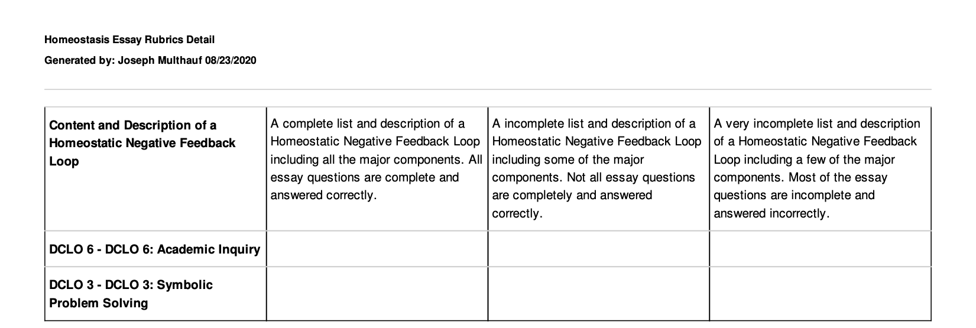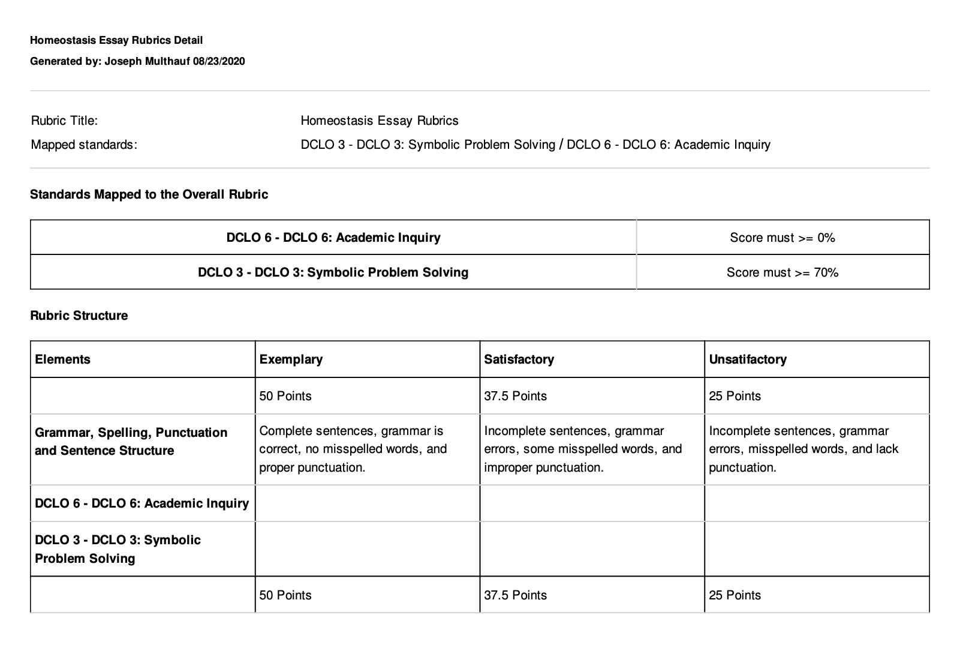

Common Read Events 2021 - 2022

Date | Event  Description | DCLO &  Theme | Organizers
August 19, 2021  (Thursday)  ALL 9AM AND 11AM CLASSES REQUIRED TO ATTEND | Convocation –  As is the custom of Catholic institutions of higher learning, we begin & end each academic year with prayer. Following an academic charge from the president, all gather for Mass. | DCLO #7  Values: Students will demonstrate moral and ethical behavior in keeping with our Catholic identity.  Theme: Faith & social justice | Campus Ministry  Student Life  Academic & Student Affairs
 | The Archbishop will be given a copy of the Common Read & may reference it in his homily.
September 9,  2021  (Thursday) 11AM-12:30PM  -ALL 11AM CLASSES REQUIRED TO ATTEND | Guest Lecture –  President Steve Minnis | DCLO #4  Analytical Thinking: Students will employ reflective thinking to evaluate diverse ideas in the search for truth. | Library  Campus Ministry Student Life
October 5, 2021  (Tuesday)  9AM-ALL 9AM CLASSES REQUIRED TO ATTEND | Film – “Hotel  Rwanda” | DCLO #3  Symbolic Problem Solving: Students will demonstrate proficiency in information literacy skills. | Student Life
 |  | Theme: Crisis & Resistance

November 10,  2021  (Wednesday) ALL 9AM AND 11AM CLASSES ARE REQUIRED TO ATTEND | Author --  Immaculee Ilibagiza, Rwandan survivor and author of Left to Tell | DCLO #5  Personal and Interpersonal Skills: Students will develop an understanding across cultural differences locally, nationally, and internationally. | Student Life  Campus Ministry
 |  | Theme: Hope
February 22, | Guest Lecturer | DCLO #2:  Technology and Information Literacy: Students will demonstrate proficiency in information literacy skills.  Theme: Civic Engagement | Library
2022 | – Maureen |  | Student Life
(Tuesday) | Mahoney
11AM-ALL
11AM
CLASSES
REQUIRED
TO ATTEND
March 16, 2022 | Student Refugee | DCLO #1: | Student Life
(Wednesday) | Panel | Communication
1:00-ALL |  | Skills: Students
1;00PM |  | will
CLASSES |  | communicate
REQUIRED |  | effectively in
TO ATTEND |  | writing and
 |  | speaking.
 |  | Theme:
 |  | Perseverance
April 5, 2022 | Student Expo | DCLO #6: | Student Life
(Thursday) 10:15-11:00  AND 12;15-1;00 |  | Academic Inquiry: Students will  engage
International Day |  | independently  and effectively in
of Reflection on |  | lifelong learning.
the 1994
Rwandan
Genocide

FINALS SCHEDULE FALL 2021:
Monday, December 6: Last day of classes for FA2021 term Tuesday, December 7: Study Day -More info. to follow
Wednesday, December 8: Finals for Mon/Wed classes during class time

Thursday, December 9: Finals for Tue/Thu classes during class time

Sunday, December 12: Grades due by 11:59 p.m. Friday, December 17: Faculty Last Day on campus

Important Dates

Day of Service Saturday August 14 (required) Day and Evening Classes Begin Monday August 16 Convocation Thursday August 19 (required) Labor Day (College Closed) Monday September 6 Thanksgiving Break (College Closed) November 24 - 26
Finals December 8 - 9

