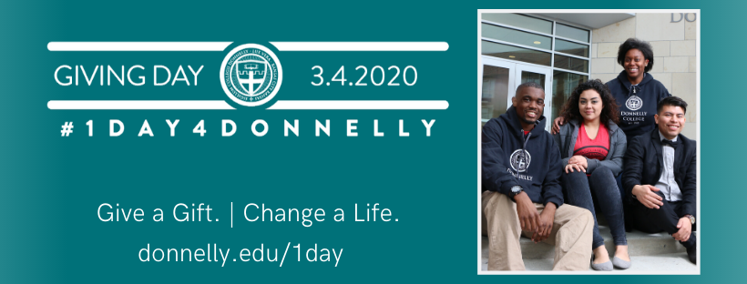
1Day4Donnelly Ambassador Guide
1Day4Donnelly Ambassadors create awareness of Donnelly College and inspire donations during our 24-hour giving event on March 4, 2020. Anyone engaged with Donnelly (Alumni, friends and beyond!) can be a 1Day4Donnelly Ambassador.
As an ambassador, you spread the word by engaging others to post 1Day4Donnelly content to your social media pages. Scroll down to find sample hashtags, photos, text and other ambassador tools.
How to be a 1Day4Donnelly Ambassador
- Contact Erika Rothacher at erothacher@donnelly.edu to sign up
- Share/retweet 1Day4Donnelly content from the Donnelly College accounts
- Change your social media cover photo to the 1Day4Donnelly cover photo
- Add a 1Day4Donnelly frame to your Facebook profile picture
- Message your friends to invite them to donate (Everyone can donate—Including You!)
- Have fun!

Follow us on Social Media
Facebook: https://www.facebook.com/DonnellyCollege/
Instagram: https://www.instagram.com/donnellycollege/
Twitter: https://twitter.com/DonnellyCollege

Use the Official Hashtag: #1day4donnelly
Sample Posts Prior To 1Day4Donnelly
- On March 4, 2020 Donnelly College will come together for our first annual 24-hour giving event. How will you make a difference? Go to www.donnelly.edu/1day to learn more!
Sample Posts On March 4th, 2020
- #1Day4Donnelly starts NOW! Make a difference with your gift at www.donnelly.edu/1day
- Only a few hours left of #1Day4Donnelly! Make a difference with your gift at www.donnelly.edu/1day
Or answer these questions in your post
*Don’t forget to always use the #1day4donnelly hashtag & encourage people to give at www.donnelly.edu/1day
- I just donated to Donnelly College during #1Day4Donnelly because …
- To me, Donnelly College means …..
- My favorite memory from my time at Donnelly College was….

