Do

2021-2022
Updates: Year 5

DONNELLY COLLEGE STRATEGIC PLAN
Donnelly College is a Catholic institution of higher education that seeks to continue the mission of Jesus Christ in our time by making the love of God tangible in our world. Specifically, the mission of Donnelly College is to provide education and community services with personal concern for the needs and abilities of each student, especially those who might not otherwise be served.

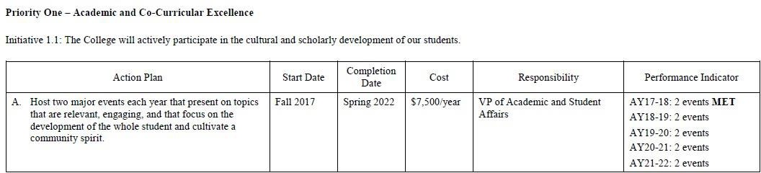

Year 1 Updates
Spring 2018:
- “Documenting the Undocumented,” presented by Dr. Marta Caminero-Santangelo, Professor of English and Director of the Center for Latin American and Caribbean Studies at the University of Kansas (October 17, 2017).
- “The Hatred of Poetry,” presented by Ben Lerner, Distinguished Professor of English at Brooklyn College (April 27, 2018).
- Performance Indicator for AY17-18: MET
Year 2 Updates
Spring 2019:
- March 9, 2019 Fr. Fredis Sandoval: "Catholic Social Justice and Human Rights Violations in El Salvador.”
- April 24, 2019 NEH Speaker Series-Sr. Susan Wood, Professor of Theology "Ecumenical Church Teachings."
Year 3 Updates
Spring 2020:
- Sept. 20, 2019: Common read author, Ken Ilgunas, "Trespassing Across America"
- Feb. 27, 2020: Poet Laureate of Kansas, Huascar Medina provided by Humanities Kansas.
Year 4 Updates
Spring 2021:
  - October 7, 2020: “They Changed My Name” Jose Faus, speaker, teacher, artist, and founder of the Latino’s Writers Collective in Kansas City.
  - This presentation brings together the dynamics of immigration told through the lens of visual art and poetry. It showcases an interactive exploration of a personal journey from the heart of Colombia to the heart of the United States, exploring the conundrum of belonging in unfamiliar surroundings while straddling two different cultures and narratives.
  - March 2, 2021: Common Read Author, Dr. Mona Hanna-Attisha, “What the Eyes Don’t See”
  - Common Read events proved successful in both attendance and student evaluations.
  - Intramurals returned in Spring ’21.
  - Partnered with Campus Ministry to hold several events, including Lenten Lunches.
  - Addition of the Social Justice Club.
  - With a modified format due to COVID, Thanks and Giving Event
  - March 11, 2021: Pi Day was celebrated in-person with a smaller group of students and simultaneously broadcasted to other classrooms. Local high schools were provided the link to join the celebration. Leading to the celebration we had a Pi Day 2021 Virtual Artistic Contest. This was an online creative art contest; students were invited to submit any type of original art work that represented Pi (π).
Year 5 Updates
Fall 2021:
- September 9, 2021: Catholic Identity: Stephen D. Minnin from Benedictine College
- November 10, 2021: Immaculee Ilibagiza, Common Read author, Left to Tell

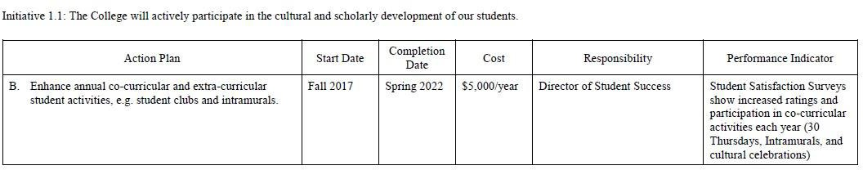

Year 1 Updates
Spring 2018:
  - The Nursing Department added the Student Nurses Association.
  - Fall 2017, Power Hour was rebranded as "30 Thursdays" to increase student participation and attendance.
  - Full-time Program Support Specialist
Year 2 Updates
Spring 2019:
  - Intramurals-Volleyball, soccer, and basketball
  - Pro-Life Club
  - Our Lady of Guadalupe Celebration-Dancers

Year 3 Updates
Spring 2020:
- Implementation of Common Read events to replace “30 Thursdays ”to increase attendance and engagement by requiring whole classes to attend and actively participate.
- Reboot of Soccer Club, one of the college's oldest clubs.
- Addition of two new clubs: Running Club & Girls Who Code.
- Fall Festival: each club hosted an event in one day. Clubs have expressed interest in making this an
annual activity.
- Boosted Pi Day, a campus tradition, by inviting local schools to participate Rosedale Middle School and J.C. Harmon High School.
- Student Senate had their recent elections and elected 5 new members.
- Pro-Life club took over 42 students to Washington D.C. for the March for Life.
Year 4 Updates
Spring 2021:
  - Common Read events proved successful in both attendance and student evaluations.
  - Two new student clubs were added: Students for Social Justice and Travel Abroad.
  - Intramurals returned in Spring ’21.
  - Partnered with Campus Ministry to hold several events, including Lenten Lunches.
  - Addition of the Social Justice Club.
  - With a modified format due to COVID, Thanks and Giving Event
    - March 11, 2021: Pi Day was celebrated in-person with a smaller group of students and simultaneously broadcasted to other classrooms. Local high schools were provided with the link to join the celebration.
    - Leading to the celebration we had a Pi Day 2021 Virtual Artistic Contest. This was an online creative art contest; students were invited to submit any type of original artwork that represented Pi.

Year 5 Updates
Spring 2022:
- Continued Common Read events for 2021-22.
- Intramurals in volleyball, basketball, and soccer were offered.
- Added Salsa Club and First-Gen Men Club
- Continued partnership with Campus Ministry

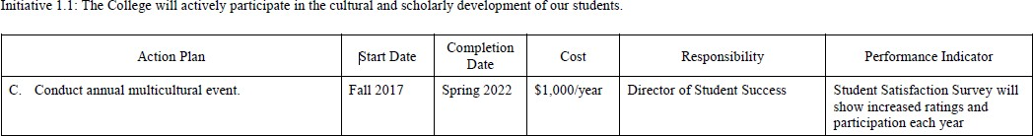

Year 1 Updates
Spring, 2018:
- Multicultural Fest was held on April 29, 2018 with many cultural and ethnic groups represented. We assessed the survey and will reorganize event to offer in the Fall 2018 so that it’ll attract more students and families.
- AY17-18 MET

Year 2 Updates
Spring, 2019:
- Multicultural Fest moved to Fall 2018 and held in the Event Center. Increased participation in ethnicity and country presentations by 50%. Held on October 12, 2019.
- AY 18-19 MET

Year 3 Update
Spring 2020:
- Multicultural Fest-Continued the same format as previous years and noted that we did not have as high attendance as usual. Move this event to spring once students are acclimated with college life.
- Initiated discussion on making the event more faculty led as well as incorporating it into the curriculum.

Year 4 Updates
Spring 2021:
  - Multicultural Festival was added as a Common Read event, boosting participation.

Year 5 Updates
Spring 2022:
- Multicultural Festival was again held in the Spring which encouraged more participation from students

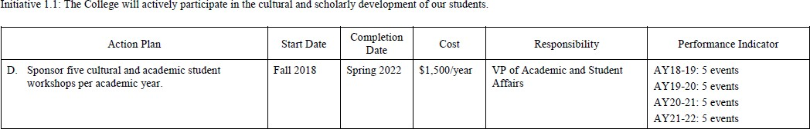

Year 2 Updates
Spring 2019
  - October 15, 2018-Lewis Morrow and Theater Company-Original Production
  - November 15, 2018, Thanks and Giving-Celebration of Community
  - February 14, 2019-Kim Staley Writing Workshop: "Moment by Moment: Family History Writing Workshop”
  - February 19, 2019 -Phil Dixon- “The Kansas City Monarchs and the History of the National Negro League of Baseball”
  - March 8, 2019-Donnelly College and The University of Kansas Creative Writing Workshop
  - April 29, 2019-Assessment Day for staff, faculty, and students

Year 3 Updates
Spring 2020:
  - Convocation August 2019
  - Common Read Author Series-September 10, 2019
  - Four Corners Debate- Oct. 16, 2020
  - Pi Day-March 12, 2020
  - Student Expo-February 12, 2020
    - All other events cancelled in spring 2020 due to COVID

Year 4 Updates
Spring 2021:
  - Convocation August 2020 (in small groups and exclusively attended by First-Year Experience students due to Covid)
  - October 19, 2020: “Say It Loud, I Matter” spoken word artist, Jessica Ayala, performed poetry and presented on activism and self-acceptance.
  - February 17, 2021: Role of research Panel, a panel of researchers, scientists, students, and professors shared how they've used research to make a difference in their community.
  - March 2, 2021: Common Read Author Series
  - March 11, 2021: Pi Day
  - April 22, 2021: Student Expo
  - April 23, 2021: DIME Release, DIME is the Arts and Literary Journal of Donnelly College.
  - June 8 – July 29, 2021 – Summer STEM Academy: Since Summer 2019, Donnelly has hosted an annual Summer STEM Academy for incoming and continuing STEM students. The 2019 program was a three-week pilot which was expanded to five weeks in 2020 (but offered in a hybrid format due to the pandemic). This summer we have returned to in-person activities and expanded the program to eight weeks.

Year 5 Updates
Spring 2022:
- August 2021 – Erik Smith, Financial Literacy
- October 2021 – Gene Chavez, Hispanic Heritage Month “Flour Power
- April 2022 – Rabbi Moti Rieber, Kansas Interfaith Action
- April 2022 – Multicultural Festival

Initiative 1.2 The College will use Assessment data to develop curricula and programs.

Action Plan | Start Date | Completion Date | Cost | Responsibility | Performance Indicator
- Develop a framework to develop and analyze | Fall 2017 | Fall 2018 | $2000 | Assessment Council | Framework
assessment data to |  |  |  |  | Developed-MET
inform continuous |  |  |  |  | Framework
program improvement. |  |  |  |  | Implemented-MET

Year 1 Updates

Spring 2018:

- The framework has been developed and approved by the Student Learning Outcomes Committee and the Assessment Council. MET
- The framework has been implemented and new Assessment Plans are being executed. MET

Year 2 Updates
Spring, 2019
    - Framework developed, included in Assessment Handbook MET

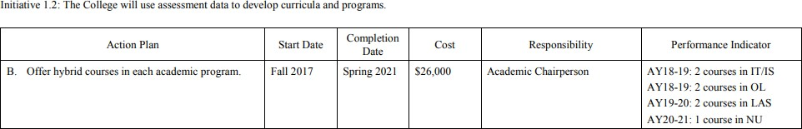

Year 1 Updates
Spring 2018:

      - Due to the redirection of focus on the HLC directives and the changes to LMS platforms, the IT/IS courses have not been identified nor developed into hybrid delivery formats.
      - With the implementation of the new LMS (Canvas) beginning in June 2018, the delivery date for these courses in a hybrid method will start in AY 18-19.

Year 2 Updates
Spring 2019:

      - Two hybrid courses were offered in Information Systems in Spring, 2019 (IS 304 and IS 311). Hybrid courses in Organizational Leadership were not offered due to a transition in leadership in the department. Assessment Council of Donnelly College is discussing hybrid course offerings for Liberal Arts and Sciences classes for Spring, 2020.

Year 3 Updates
Spring 2020:
    - The Department of LAS is considering hybrid courses but is collecting assessment data to ascertain if 100-200 level courses are the best option for hybrid. Due to COVID-19, all courses were taught in distance learning format after March 23, 2020 and that data will be used to assess effectiveness.
In addition, a Distance Learning Handbook was approved by the College in Spring 202 and the college received permission from HLC to offer online courses from March 23, 2020 to September 1, 2020.

Year 4 Updates
Spring 2021:

  - LAS is preparing to start offering Hybrid Classes Spring 2022. We are currently exploring: PY101 or PY 205, a new science 3-credit elective, a history course and BL136- Anatomy & Physiology

Year 5 Updates
Spring 2022:
- LAS approved and began offering some of these courses in online or hybrid modality starting in SPS22 semester.
List of Approved ONLINE Courses for LAS by the end of AY 2021-2022
EN111 - English Composition I
EN112 - English Composition II
PY101 – General Psychology
PY205 – Human Growth & Development
GE101 – World Geography
PH112 – Philosophy of the Human Person
PH 210 – Introduction to Philosophy
EN140 – Public Speaking
MT130 - College Algebra
RS225 – Foundations of Theology

List of Approved HYBRID Courses for LAS by the end of AY 2021-2022
BL101 (lecture) – Principles of Biology
BL136 (lecture) – Human Growth and Development
HS121 – Early American History
CH103 – Chemistry of Everyday Phenomena
PY101 – General Psychology
PY205 – Human Growth & Development
FA104 – Survey of Art
EN111 - English Composition I
EN112 - English Composition II
GE101 – World Geography
IT111 – Business IT Applications

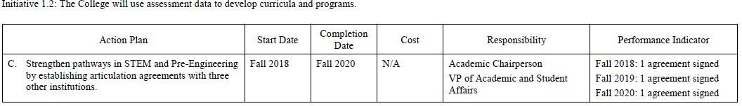

Year 1 Updates
Spring 2018
- Donnelly is building STEM program capacity through multiple current federal grants, two from the National Science Foundation and two from the Department of Education. The most recent grant is a collaborative project with University of Missouri-Kansas City’s School of Computing
& Engineering.

Year 2 Updates

Spring 2019:
- Signed MOU with Park University in Parkville, MO in the field of Secondary Education. Students seeking secondary certification must select one of the following areas of certification:
- Biology, Chemistry, Earth Science, English, Mathematics, Social Science

Year 3 Updates
Spring 2020:
    - An initial meeting was held in fall 2019 with Kansas State University and Dr. Brenee King to discuss an articulation agreement in the areas of Computer Science and Computer Engineering pathways. Donnelly has sent course curriculum to K State for evaluation.
    - In March 2020, Lisa Stoothoff, VPASA started discussions with Monica Espinosa, EPA for a MOA to provide STEM related lectures, seminars, and collaborations. This MOA is expected to be signed on September 21, 2020. This MOA will allow EPA professionals to enhance our curriculum with speaker series.

Year 4 Updates
Spring 2021:
  - On September 21, 2020, Donnelly College and EPA Region 7 signed an MOU formalizing an expanded five-year partnership to promote environmental education and career opportunities for Donnelly students.
  - Articulation Agreement with Metropolitan Community College - On February 25, 2021, Donnelly signed an articulation agreement to facilitate the transfer of associate degree graduates from Metropolitan Community College (MCC) into our Bachelor of Science in Information Systems.

Year 5 Updates
Spring 2022:
- Ana Maradiaga and Lisa Stoothoff co-wrote a grant led by the University of Kansas to build more adaptive and resilient research infrastructure for next-generation technology development.
https://www.nsf.gov/news/special_reports/announcements/051622.jsp
https://davids.house.gov/media/press-releases/davids-announces-new-statewide-research-initiative-disaster-relief

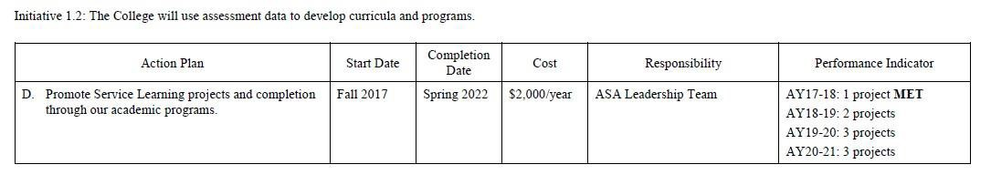
Year 1 Updates
Spring 2018:
- Project LOUD (Literacy Outreach in Urban Districts) establishes a reading partnership between Developmental Education students at Donnelly College and at-risk elementary students at public and Catholic schools in the urban core. To prepare for the project, Donnelly Preparatory Education students spend six weeks reading a wide range of poetry—from published poets to contemporary rappers—and then using these examples to compose their own original poetry. Each Donnelly student then select a variety of published and original works to read to and with the two or three elementary school students with whom they are paired. For AY17-18, the project was carried out at Holy Name Catholic School on Southwest Blvd. in KCK.
- AY 17-18 MET

Year 2 Updates
Spring 2019
- Unbound-Letter Writing Service-Learning Project- Fall, 2019 Project LOUD-Literacy Outreach Urban Districts-Spring, 2019 Social Justice Trip-Memphis Tennessee-May 2019
*In addition to the service-learning projects, we created our first Global Civics course which is a one credit accompaniment to the May Social Justice trip.

Year 3 Updates

Spring 2020:
    - The annual social justice trip and corresponding 8-week course (CV100) were cancelled due to the COVID-19 crisis.
    - Success First implemented their Project LOUD (Literacy Outreach in Urban Districts)
    - Success First collaborated with UNBOUND and the CCS100 students on a letter-writing initiative.
    - The Environmental Ethics course was unable to complete its civic engagement component due to COVID.

Year 4 Updates
Spring 2021:
  - Fall 2020 - Biology and Chemistry students measured levels of nitrates, phosphates, salinity, carbon dioxide, pH and heavy at Big Eleven Lake and cleaned up the park area.
  - Spring 2021 – Environmental Ethics course worked with the Sierra Club to educate urban core residents about the saving energy and distributed LED light bulbs Environmental ethics students also planted a community garden at a local public housing project, Wyandotte Towers.
  - STEM faculty revised a course and added a lab component to an existing Environmental Science class that has not been offered in many years. The revised Environmental Science course will be team taught in fall 2021 and will also include a service-learning component that encourages STEM career exploration.

Year 5 Updates
Spring 2022:
- August 2021 – Day of Service https://www.kcur.org/news/2022-05-25/a-small-college-in-kansas-city-kansas-wants-climate-justice-at-the-center-of-everything-it-does

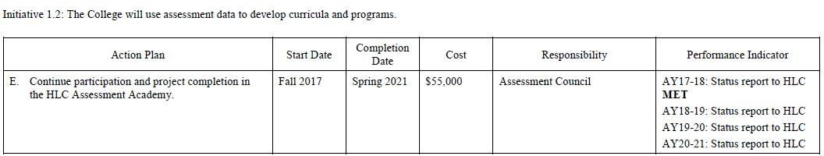

Year 1 Updates
Spring 2018:

- Secured a grant from the Ewing Marion Kauffman Foundation in July 2017 for
$51,573 to support Assessment Academy participation.
- Status report submitted to HLC/Academy Mentor. Received response from Academy Mentor and changes will be implemented in the next report.

Year 2 Updates
Spring 2019
- In July 2019, the Assessment Academy, Jennifer Bales, Mary Pflanz, Melissa Lenos, Joe Multhauf and Lisa Stoothoff, attended the Mid-Point session of the Assessment Academy in Chicago, IL. This working session provided a clear pathway to our next steps in the Assessment process. The final report and project are due in Summer 2021.

Year 3 Updates
Spring 2020:
  - The Assessment Academy meets with our HLC consultant, Marianne Danielson, on quarterly basis to report progress on our Academy Project. Our annual Assessment Day is being held on August 18, 2020.

Year 4 Updates
Spring 2021:
  - In June 2021, the team from Donnelly College graduated from the HLC Assessment Academy during a virtual event. These four-year processes strengthened our culture of assessment and has propelled us to offer Assessment Days, involve the entire college in assessment measures and increase student awareness of student learning outcomes.

Year 5 Updates
Spring 2022

MET

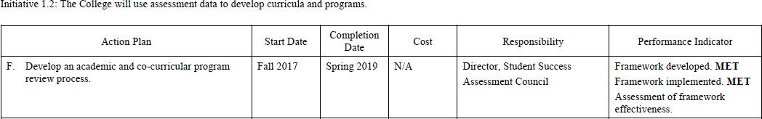

Year 1 Updates
Spring, 2018
- Program Review framework and process developed for both academic and co- curricular programs. MET
- A Program Review rubric has been developed and implemented. MET
- Program Review process has been implemented and reports are being evaluated by the Assessment Council.
Year 2 Updates
Spring 2019:
- Program Review Process completed and implemented.

Year 3 Updates
Spring 2020:
    - A subcommittee of Assessment Council met in June 2020 to assess the framework and to develop a new timeline for assessment plans and to “close the loop” on the Program Review process

Year 4 Updates
Spring 2021:
    - A subcommittee of Assessment Council met in June 2021 to create a new Program Review template and rubric better suited to assess co-curricular programming. These will be implemented in the next Program Review for Student Support Service
Year 5 Updates
Spring 2022:
- Revised the Program Review process to include staff departments starting in January 2023.
- The first round of Program Reviews for all academic departments was completed between 2018-2022. Program Reviews will continue for all academic departments on a rotating basis. Program reviews for non-academic departments will begin in 2022-2023.
- In 2021-2022 the college switched from using Via for assessment of individual courses to using Canvas to assess student learning outcomes. Canvas has proved a more user-friendly and cost-effective way to evaluate SLOs. At the end of each semester, each department looks at the SLO assessment data and make recommendations for continuous improvement.
- 2021-2022 -- Donnelly gained HLC approval to offer more online courses and used grant money to revise many existing courses in most disciplines to have the option of being offered as hybrid or online courses.
- 2020-2021 -- Success First began offering co-requisite courses for upper level developmental English students. This research-based approach allows students to begin college-level English courses (Composition I) while being supported in a co-requisite Success First Accelerated Reading and Writing course.
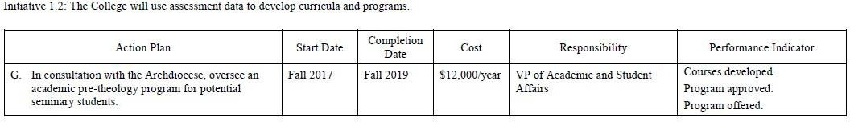
Year 1 Updates
Spring 2018

      - At this time, we are only offering Philosophy courses; students seeking to take these courses, may also be enrolled in other academic programs at DC.

Year 2 Updates
Spring 2019

      - An outline of the program requirements has been established by the Director of Institutional Research.
The Endowed Chair of Humanities is now compiling those documents.

Year 3 Updates
Spring 2020
    - An ad-hoc committee was created to discuss the possibility of a Pre-Theology Program. The committee consisted of faculty members, the academic librarian, campus ministers, and advisor and the Endowed Chair of the Humanities.
    - The committee found that it was not feasible to start
the program as it was not fiscally responsible or was there a need for a program in our area.

Year 4 Updates
Spring 2021:

None

Year 5 Updates
Spring 2022:

None
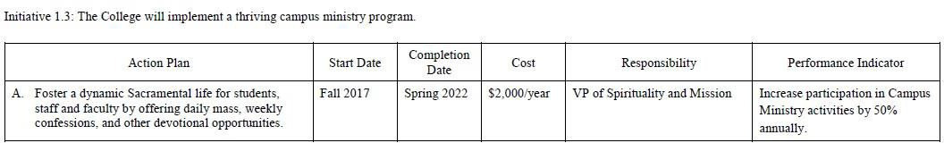
Year 1 Updates
Spring 2018:
      - Daily Mass is offered for faculty and students. Sacramental Confession is offered on Wednesdays and Thursdays. Ash Wednesday Services.
      - Pre-seminary students conducted Ash services.
      - The Holy Rosary and Stations of the Cross offered on Wednesdays and Fridays of Lent. Increase event participation annually by 50%, using baseline data for AY17-18: ▪ Daily Mass: 10 (average) ▪ Sacramental Confession: 10 (average) ▪ Ash Wednesday Mass: 30 (average) ▪ Holy Rosary: 10 (average)

Year 2 Updates
Spring, 2019:
      - A Student Work Study was added to Campus Ministry to engage students in a "Like evangelizes like" approach. Experimentation in finding good times for Masses and other Sacramental celebrations. Increase in the use of the Sacrament of Reconciliation.
      - Hire a full time Assistant in Campus Ministry to assist in developing more dynamic and interactive programs.

Year 3 Updates:
Spring 2020
- Daily Mass is offered for faculty and students.
- Sacramental Confession was offered daily.
- Instituted Daily Morning Prayer according to the Liturgy of the Hours.
- The Holy Rosary daily during October and November.
- Began a weekly Pro-life Rosary / Prayer Sessions
- Full time Assistant was hired
- Four Donnelly students went on a Koinonia retreat

Year 4 Updates
Spring 2021:
  - Daily Mass offered for faculty and students: Monday through Friday at 12:05 PM.
  - Sacrament of Confession offered any time by request and twice a week before Mass: Tuesday and Friday from 11:00 – 11:45 AM
  - Eucharistic Adoration offered twice a week before Mass: Tuesday and Friday from 11:00 – 11:45 AM
  - The Holy Rosary prayed daily during the month of May

Year 5 Updates
Spring 2022:

  - Daily Mass offered for faculty and students: Monday through Friday at 12:05 PM.
  - Sacrament of Confession offered any time by request and twice a week before Mass: Tuesday and Friday from 11:00 – 11:45 AM
  - Eucharistic Adoration offered twice a week before Mass: Tuesday and Friday from 11:00 – 11:45 AM
  - The Holy Rosary prayed weekly on Wednesdays
  - Twelve students and staff attended a spiritual retreat at the Monastery of the Community of the Lamb in Kansas City, KS.

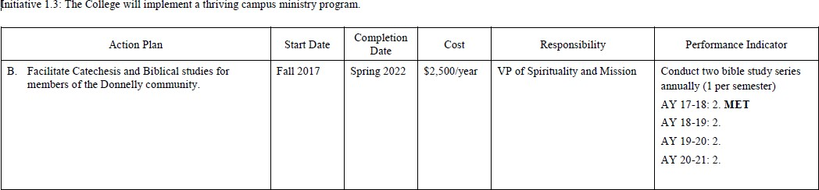
Year 1 Updates
Spring 2018:
- Theological Discussion groups held for informal formation.
- “Faith Matters” discussion group at Sanctuary of Hope, an ecumenical retreat center in urban Kansas City, Kansas.
- Results from the Campus Ministry Survey discussed in 1.3C will also inform this action.

Year 2 Updates
Spring 2019:
- Two Bible Studies were hosted on Campus. During the Fall Semester a program called "Movies, Munchies & Meditation" focused a Bible Study using Contemporary Film. (Bro. Martin). In the Spring Semester a Regular Bible Study was offered during Lent. (Cheryl Hicks)
- The need to acquire more Bibles and study texts. Need to make Regular Bible study more engaging and featured as a part of campus life.

Year 3 Updates
Spring 2020:
    - Tuesdays: Theology & Tapas weekly, in the Donnelly commons., Br. Martin hosted a Theology and Bible discussion. A lot of energy expended on correcting students’ misunderstanding of Catholic teaching – partially because of what they have heard from media and even various faculty members.
    - Focus on Catholic Morality. Students have a radical misunderstanding of homosexuality, “same sex” marriage, Divorce, Marriage. Several students have been formed in the MISUNDERSTANDING that truth is “relative”. Some faculty members have inculcated into students the sense that truth is relative, and “Socialism” is compatible with Catholic Social teaching. Much energy was focused on correcting error.
    - Made free Bibles and Catechisms available to any interested students. Seriously, we are “starting from scratch” when it comes the faith awareness and understanding of virtually all of our students, AND MOST OF OUR FACULTY!!!
- Thursdays in the Commons: Weekly Catechetical Study.
- During the Fall Semester "Movies, Munchies & Meditation" focused Christian Values Study using Contemporary Films. (Bro. Martin).
- Guadalupe: Three Documentary films on Faith in the Latin X tradition. In conjunction with the Feast of Our Lady of Guadalupe.
- Campus wide subscription to “FORMED.ORG” and FOCUS-EQUIP App as a way of engaging students and staff during the Campus wide shut down of COVID-19
- Weekly Online catechesis and discussion of featured programming from “FORMED” and “FOCUS”.

Year 4 Updates
Spring 2021:
  - Bibles were given to all incoming students at Convocation to begin the school year
  - Weekly student Bible study was held during the spring semester
  - Foundations of Theology (RS 225) was taught by the campus minister and offered as preparation for those seeking to complete the Sacraments of Initiation

  - Began individual student preparation for the sacrament of Confirmation
  - Began individual staff preparation for the sacrament of Confirmation
  - Met with students one on one to discuss contemporary religious issues. Students were especially interested in the Catholic understanding of the human person, marriage and sexuality.
  - Campus minister taught an elective class (PH 112) on the Philosophy of the Human Person from a Catholic perspective
  - Campus wide subscription to “FORMED.ORG” and FOCUS-EQUIP App as a way of engaging students and staff

Year 5 Updates
Spring 2022:

- Offered a one hour elective on Catholic theology – Survey of Catholic Belief – taught by the campus minister.
- Foundations of Theology (RS 225) was taught by the campus minister and offered as preparation for those seeking to complete the Sacraments of Initiation.
- Began individual student preparation for the sacrament of Confirmation
- Met with students one on one to discuss contemporary religious issues
- Campus wide subscription to “FORMED.ORG” and FOCUS-EQUIP App as a way of engaging students and staff

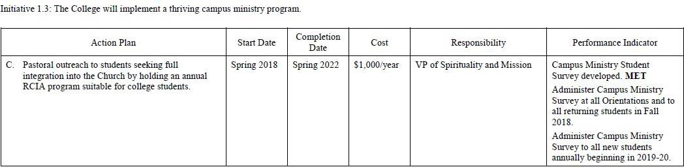
Year 1 Updates
Spring 2018:
- Prepared a campus ministry survey for new and returning students to determine their Sacramental needs.
- Shared survey with Cabinet and Student Services for incorporation at New Student Orientations held Summer 2018.
- Outlined strategy to also survey all returning students in Fall 2018.
- Individual Catechesis to candidates for Confirmation. (conducted by Br. Martin Navarro & Sr. Marie Kathleen Daugherty)
Year 2 Updates
Spring 2019:
- Campus Ministry Student Survey developed.
- Administer Campus Ministry Survey at all Orientations and to all returning students in Fall 2018.
- Administer Campus Ministry Survey to all new students annually beginning in 2019-20.

Year 3 Updates
Spring 2020
    - Enhanced our existing Campus Ministry Student Survey for more specific data
    - Administered Campus Ministry Survey at all Orientations and to all returning students in Fall 2019
    - Individual Catechesis and R.C.I.A. Individual Catechesis to candidates for Confirmation. (Conducted by Br. Martin Navarro, Fr. John & Sr. Marie Kathleen Daugherty)

Year 4 Updates
Spring 2021:
  - Foundations of Theology (RS 225) was taught by the campus minister and offered as preparation for those seeking to full integration into the Church
  - Administered Campus Ministry Survey at all Orientations and to all returning students in Fall 2020

Year 5 Updates
Spring 2022:

- Students met weekly for RCIA Inquiry
- Prepared students for the sacraments of initiation.
- Four students received sacraments at the Easter Vigil. Two were baptized, confirmed, and received first communion. Two more were confirmed

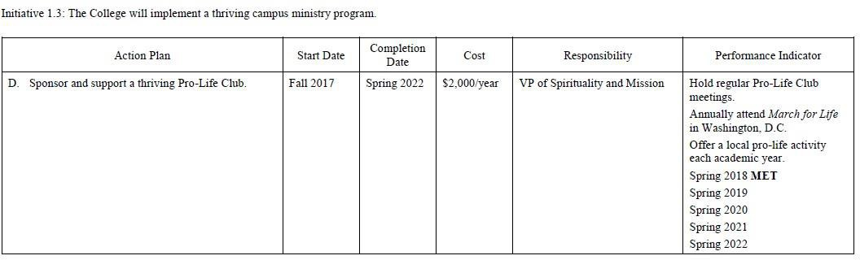
Year 1 Updates
Spring 2018:
- Students participated in the national March for Life rally in Washington, DC. MET
- A Pro- Life Club has been formed and began meeting.
- Lisa Stoothoff, VP of Academic & Student Affairs, is the Faculty Advisor, together with Fr. John Melnick, VP of Spirituality and Mission.
- Student participated at the National Pro-Life Convention in Kansas City, KS June 29-30.
- This club is already preparing for the 2019 Pro-Life March in Washington, DC.

Year 2 Updates
Spring 2019:
  - Hold regular Pro-Life Club meetings.
  - Annually attend March for Life in Washington, D.C.
  - Offer a local pro-life activity each academic year.
- Meetings were held bi-weekly in order to organize the first-ever full-bus trip of Donnelly students to the March for Life in Washington, D.C. Additionally, students were constantly active in promoting the movie Unplanned to students on campus and attending the Premiere the week prior to its release. Most meetings are concerned with fundraising rather than student outreach; the club was only able to acquire $50 from the Student Senate.

Year 3 Updates
Spring 2020
- Weekly Pro-Life Club meetings. The club grew to 72 Students.
- Yarelli Castor, Ian Suarez, Angie & Kritshna Diaz elected officers.
- Promotion of the Club in the various Wyandotte Country Churches. The club was able to raise $7000 (plus) for the annual Pro-Life March-trip.
- 40 students-Faculty attended March for Life in Washington, D.C. Jan. 22-26, 2020
- Offer of local pro-life activities each academic year. (1) Sponsored the movie “Unplanned” on campus, with an ‘Ice cream Social’, (2) Bake Sale (3) Co-Sponsored with Campus Ministry and STEM: a Study Day with Dr. Pilar Calva.
M.D. and Dr. Mercedes Wilson
- Off Campus the Pro-Life club promoted Terry Beatley in cooperation with the Archdiocesan Pro-Life
- Meetings were held weekly to organize the annual Washington trip of Donnelly students to the March for
- Life in Washington, D.C.
- Most meetings focused on student outreach education.
- The club developed a Facebook page and worked on a number of pro-life videos

Year 4 Updates
Spring 2021:
- Weekly Pro-Life Club meetings in the fall semester
- Ian Suarez and Kritshna Diaz elected officers.

- March for Life trip was canceled due to COVID-19
- Plans for the following academic year (‘21-’22) were made with a focus given to local crisis pregnancy outreach and the March for Life
- Organized an adjusted Convocation for all incoming students. Held four separate ceremonies in the new chapel. The ceremonies consisted of the Liturgy of the Word and the Ceremony of Matriculation. Msgr. Swetland presided over each.
- Partnered with Student Life to offer free lunches to the Donnelly community during the Lenten season
- Students from the Foundations of Theology class created Easter Egg Trees that were displayed in front of the chapel

Year 5 Updates
Spring 2022:

- Weekly Pro-Life Club meetings in the fall semester
- Carolina Morales elected president.
- March for Life trip was canceled due to COVID-19
- Plans for the following academic year (‘22-’23) were made with a focus given to local crisis pregnancy outreach and the March for Life in Kansas
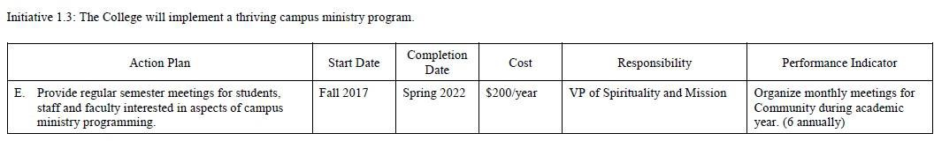

Year 1 Updates
  - Results from the Campus Ministry Survey discussed in 1.3C will be reviewed in these planning meetings in 2018-19 and inform discussion of programming plans.

Year 2 Updates
Spring 2019:
  - Two Campus wide Planning Sessions were held to prepare for Campus ministry events (composed of Students, Faculty, Staff and Administration. This will be continued and expanded.)

Year 3 Updates
Spring 2020:
- Open Campus Planning Sessions were held in Autumn of 2019 to prepare for Campus ministry events (composed of Students, Faculty, Staff and Administration.)
- Results from the Campus Ministry Survey were reviewed in that planning meeting to inform 2019-20 discussion of programming plans.

Year 4 Updates
Spring 2021:
- Presented on Campus Ministry civic engagement for the Donnelly spring community meeting. Informed Donnelly community of significant student participation in the Pro-Life Club pre-pandemic and plans to renew participation in the coming academic year. Also, informed community of the desire to expand Campus Ministry’s focus beyond but still including Pro-Life activities

Year 5 Updates
Spring 2022:
- Staff and faculty discussion group met monthly focused on the Catholic Intellectual Life and the nature and mission of Catholic Higher Education
- Office of Mission was founded to support the college’s identity as a Catholic institution of higher education and to integrate its mission into all aspects of the college.

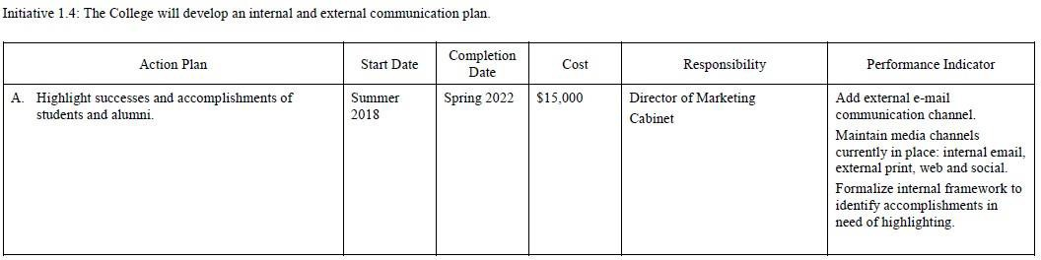

Year 1 Updates:
Spring, 2018:
  - Plans underway to expand existing communication plan to include an e-newsletter to be e-mailed to all Donnelly database in Fall 2018, supplementing the internal Donnelly Community correspondence, “The Weekly”, and the biannual external publication, the Digest.
  - Alumni Hall of Fame external website is undergoing revisions for launch in Summer 2018.
Integrate Alum Hall of Fame into SHINE annual fundraising event again in 2018 to better highlight alum success to larger audience.
  - New (internal)Alumni Committee representing advancement staff, student services staff and faculty representatives will launch in Fall 2018.
  - New Social Media strategy was launched in Spring 2018, using student-produced videos to introduce students to a larger audience. Three created and shared.
Year 2 Updates
Spring, 2019:
  - Selected highlights are presented in issues of the Digest, social media, website videos and blog.
  - We utilize testimonials and quotes on prospective student materials and development materials.
  - Selected student and alumni achievements are highlighted in special events such as SHINE and Alumni Hall of Fame.
Year 3 Updates
Spring, 2020:
- Conducted interviews with 10 current students and recent alumni. Selected highlights are presented in issues of the Donnelly Digest, social media, website, videos, advertisements, and student recruitment materials.
- Highlighted a recent alum in our most recent holiday appeal.
- Students were engaged in telling their stories and thanking donors during #1day4donnelly, part of the internal and external marketing communication plan.
Year 4 Updates
Spring 2021:
None

Year 5 Updates
Spring 2022:
- Utilized staff and faculty as outside story and testimonial curators. The Director of Marketing gave a brief presentation to the staff/faculty about the importance of being storytellers and sharing student stories with the marketing team. A traveling idea board was on campus and staff were frequently encouraged to share ideas with the marketing team.
- The marketing team gave a social media strategy presentation to the Dean, President, and VP of Advancement to share goals, data reports and strategy/best practices for different social media platforms and audiences for each. One campaign was “Meet a Dragon Scholar” to highlight student leaders and share testimonials.
- Continued to share student and alumni stories in the Digest, social media campaigns and posts, website, blog, recruitment materials, advancement appeals, SHINE, 1Day4Donnelly, etc.

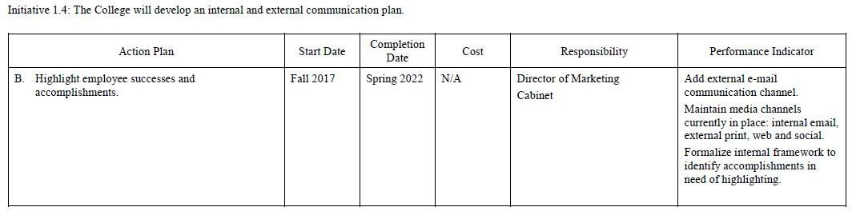

Year 1 updates
Spring, 2018
  - Plans underway to expand existing communication plan to include an e-newsletter to be e-mailed to all Donnelly database in Fall 2018, supplementing the internal Donnelly Community correspondence, “The Weekly”, and the biannual external publication, the Digest.
  - Executed current communication plan with stories about faculty and staff successes on in existing channels.
Year 2 Updates
Spring 2019:
  - Professional development activities and faculty/staff achievements are listed in the Digest.
  - Some program highlights or major achievements may be profiled in the Digest and in social media.
  - Recognition of employee achievement frequently occurs at staff and community meetings.

Year 3 Updates

Spring 2020
- Professional development activities and faculty/staff achievements are listed in the Digest.
- Some program highlights or major achievements may be profiled in the Digest and in social media.
- Recognition of employee achievements frequently occurs at staff and community meetings.

Year 4 Updates
Spring 2021:
None
Year 5 Updates
Spring 2022:
· Professional development activities and faculty/staff achievements are listed in the Digest.
· Program highlights, course spotlights and major achievements are frequently profiled in the Digest and on the website and social media.
· Recognition of employee achievements frequently occurs at staff and community meetings. Employee award recipients, including the Delta Award winner, were featured on marketing platforms.

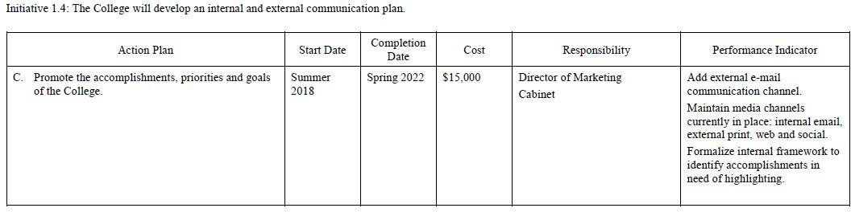
Year 1 Updates
Spring 2018:
  - Plans underway to expand existing communication plan to include an e-newsletter to be e-mailed to full Donnelly database in Fall 2018, supplementing the internal Donnelly Community email correspondence, “The Weekly”, and the biannual external publication, the Digest.
  - Donnelly’s newly adopted Campus Master Plan and new vision statement were highlighted on the cover of the Winter 2018 Digest and covered in-depth in a 4-page feature story,
  - Campus Master Plan updates and recent donors are planned to be highlighted in the Summer 2018 Digest in July, which will also highlight our academic accomplishments from Commencement in May 2018.
  - The marketing department incorporated Donnelly’s 2017 U.S. New & World Report ranking as “The Most Diverse College in the Midwest” in our Spring & Summer marketing campaign for Fall 2018, including on full-sized billboards placed on the heavily traveled nearby Interstate-70 highway.

Year 2 Updates
Spring, 2019:
  - Selected institutional highlights are presented in issues of the Digest, social media, e-mail, website videos and blog. Specifically, within the Winter Digest we include a President’s Report
  - Press releases sent for major announcements and events just as groundbreaking.
  - Institutional achievements are highlighted in special events such as SHINE and development related meetings.
  - Memberships and sponsorships of community partners events and initiatives such as the Wyandotte Economic Development Council and KCK Chamber where we often can share the latest developments at Donnelly College.
  - Development of prospective students.
Year 3 Updates:
- Selected institutional highlights are presented in issues of the Digest, social media, e-mail, website videos and blog. Specifically, within the Winter Digest we include a President’s Report.
- Press releases sent for major announcements and events just as groundbreaking.
- Memberships and sponsorships of community partners events and initiatives such as the Wyandotte Economic Development Council and KCK Chamber where we often can share the latest developments at Donnelly College.

Year 4 Updates
Spring 2021:
None

Year 5 Updates:

· Selected institutional highlights are presented in issues of the Digest, social media, e-mail, website, videos and blog. A President’s Report is included in the Winter Digest.
· Press releases are sent to local news organizations for major announcements like the Campus Dedication.
· Partnered closely with The Leaven Catholic newspaper to cover Donnelly events such as graduation and the Campus Dedication.
· Utilized the website News feature and social media to share highlights.
· Institutional achievements are highlighted in special events such as SHINE and Development Committee meetings.
· The College’s accomplishments are frequently shared in all-staff meeting

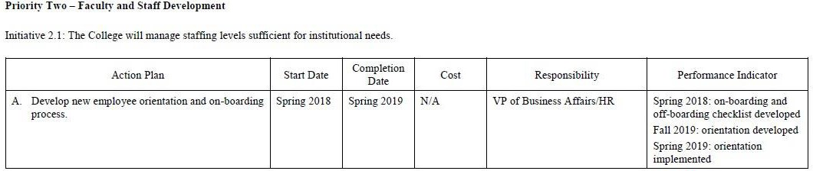

Year 1 Updates

Spring 2018:
  - Spring 2018: on-boarding and off-boarding checklist developed Fall 2019: orientation developed
Spring 2019: orientation implemented

Year 2 Updates
Spring 2019:
  - Orientation planned for development in Fall 2019 and implementation in Spring 2020.

Year 3 Updates
Spring 2020:
  - Virtus Training ongoing
  - Human Resource Specialist hired in 2019 which creates uniformity and thoroughness of onboarding process
  - Adjunct-specific training
  - College-wide workshop at the beginning of each semester.

Year 4 Updates
Spring 2021:
  - Virtus Training ongoing
  - Human Resource Specialist hired in 2019 which creates uniformity and thoroughness of onboarding process
  - Adjunct-specific training
  - College-wide workshop at the beginning of each semester.

Year 5 Updates
Spring 2022:
- Updated and improved onboarding process

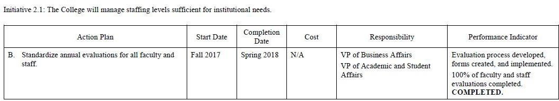

Year 1 Updates
Spring 2018:
  - The new process is being implemented in Spring 2018.
  - The process and forms are available via the HR web site.
  - All evaluations to be completed before July 31

Year 2 Updates
Spring 2019:
  - Standard annual evaluations for all faculty and staff were finalized in 2017-2018.

Year 3 Updates:
Spring 2020
- The College continues to evaluate all faculty and all staff on an annual basis.

Year 4 Updates
Spring 2021:
- The College continues to evaluate all faculty and all staff on an annual basis.

Year 5 Updates
Spring 2022:
- Created a new Staff Evaluation Form

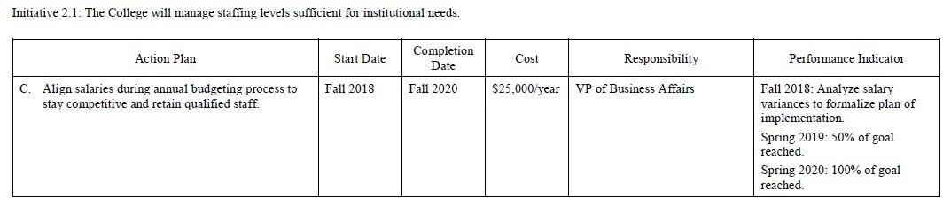

Year 1 Updates
Spring 2018:

  - Fall 2018: Analyze salary variances to formalize plan of implementation. Spring 2019: 50% of goal reached.
Spring 2020: 100% of goal reached.

Year 2 Updates

Spring 2019:

  - Salaries for 2019-20 were compared to benchmark of 25% tile from Fall 2018 KICA salary survey. In total 42 out of the 58 full-time positions were available to compare based on job title. 22 are at or above the benchmark and 20 were below. Of the 20 below the benchmark, all the cabinet level position was included, and 10 were less than a 10% variance.
Year 3 Updates
Spring 2020:

- At the Board of Directors August 2019 retreat, they were presented with financials to bring all faculty wages to a competitive level. This would require $60,000 in additional funding. To bring all employee salaries to competitive level would require an additional
$500,000 annually.

Year 4 Updates
Spring 2021:
None

Year 5 Updates
Spring 2022:
- Instituted a 6% salary increase, effective 7-1-22
- Increased some salaries to retain qualified staff and increased starting salaries for new hires

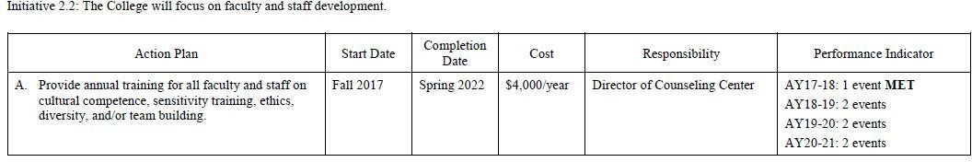

Year 1 Updates
Spring 2018:

  - AY17-18 Three workshops were offered on Goal setting, Stress Relief, and Team Building.

Year 2 Updates

Spring 2019:
  - Team Building Workshop-November 27, 2018
  - Cultural Competency Training-Spring, 2019 Faculty Workshop
  - Trauma-Informed Care-Jan./Feb. 2019

Year 3 Updates
Spring 2020:
- In Fall 2019, Gretchen Meinhardt, Director of Success First, presented on Culture and Diversity in Civic Engagement.
- Our spring presentation was cancelled due to COVID-19.

Year 4 Updates

Spring 2021:

- June 8 & 9, 2021. DEI Professional Development: “Beyond the Buzzwords” Deep Dive into Today’s most important Diversity, Equity & Inclusion Conversations.

- July 15, 2021. “Hidden Disabilities” webinar provided by Paper Clip Communications

Year 5 Updates
Spring 2022:

- Summer 2021 Staff and Faculty Equine Teambuilding and Sensitivity experience provided by Serenity Life Resource Center; three sessions May 14th, May 21st, and June 11th.
- Fall 21 – Fall 22 ‘QPR Institute Online Gatekeeper Training” Question, Persuade, and Refer (suicide) on demand.
- Summer 2022 Staff and Faculty Equine Teambuilding and Sensitivity experience provided by Serenity Life Resource Center; two sessions July 8th and July 22nd.

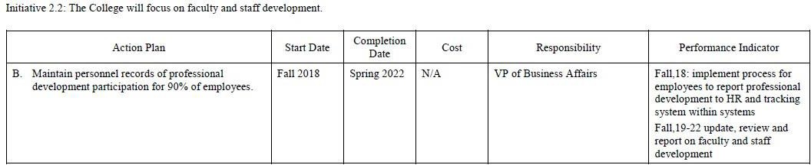

Year 1 Updates:
Spring 2018:

- Starting in FA18, all employees were required to submit documentation of professional development to the HR department.

Year 2 Updates:
Spring 2019:
  - Fall,18: implement process for employees to report professional development to HR and tracking system within systems.
  - Fall,19-22 update, review and report on faculty and staff development.

Year 3 Updates:
Spring 2020:
- In AY 19-20, all faculty received a $750 professional development stipend. These funds are to be used for conferences, travel expenses related to conferences and professional activities which enhance teaching and learning.

Year 4 Updates

Spring 2021:
- During AY2020-2021, both full-time and adjunct faculty had the opportunity to take web- based Starlink professional development modules. These modules are diverse in content but focused on promoting student success. Module completion records are kept for each faculty and staff member.

Year 5 Updates
Spring 2022:
- No updates

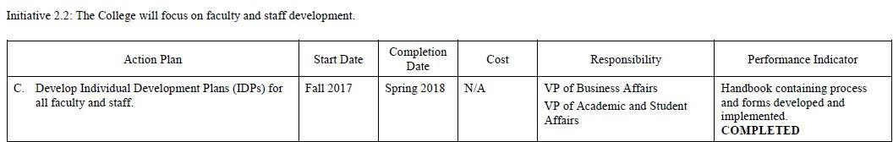

Year 1 Updates
Spring 2018:

  - Handbook and forms developed and implemented.
  - The new process is being piloted in AY17-18.

Year 2 Updates
Spring 2019:
  - This initiative was completed in 2018.

Year 3 Updates

Spring 2020:
- Each year faculty turn in their Individual Development Plans for professional development.
- The office of Academic Affairs reconciles faculty's IDP funds and email faculty their current funds amount for the new AY.

Year 4 Updates
Spring 2021:
MET 2021

Year 5 Updates

Spring 2022:

MET 2021

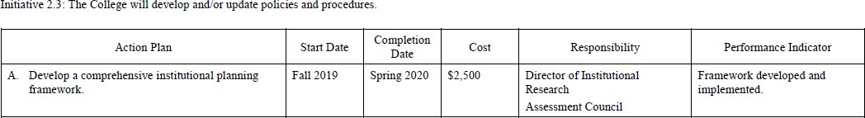

Year 1 Updates
Spring 2018:

  - Outline submitted for approval

Year 2 Updates
Spring 2019:

  - Director of Institutional Research presented three outlines for a framework based on research from different schools of thought regarding what is included in the framework. These options are being reviewed by the President's Cabinet for consideration.

Year 3 Updates

Spring 2020:
- An ideology and outline were approved by the President’s cabinet in early Spring 2020. The director of Institutional Research has brought this to the Institutional Review Board as a working project with the oversite of the committee so ensure that it follows the same principles and practices as other research guiding the College.
- Due to the COVID-19 outbreak, this project has been delayed and is anticipated to be completed by the Spring 2021.

Year 4 Updates
Spring 2021:
- Framework delayed due to COVID and job changes

Year 5 Updates
Spring 2022:

- Project abandoned due to job changes and redundancy

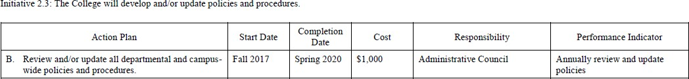

Year 1 Updates:
Spring 2018:

  - The administrative council reviewed and updated the Administrative Process and Procedure Manual

Year 2 Updates:
Spring 2019:

  - Policies updated during 2018-19 in the areas of: Advancement
Business Office
Financial Aid

Year 3 Updates

Spring 2020:
- Administrative Council meets monthly to develop and review College policy and procedures. Policies are created which are then communicated to community on a regular basis for full transparency.

- Policies approved in 19-20 include: Campus Posting Guidelines, Pass/No Pass Policy, Attendance Policy, Business Office Policies, Cost Principles for Federal Grants, Courses Not offered Regularly Policy, Green Policy, Social Media Policy.

Year 4 Updates
Spring 2021:

MET

Year 5 Updates
Spring 2022:

MET

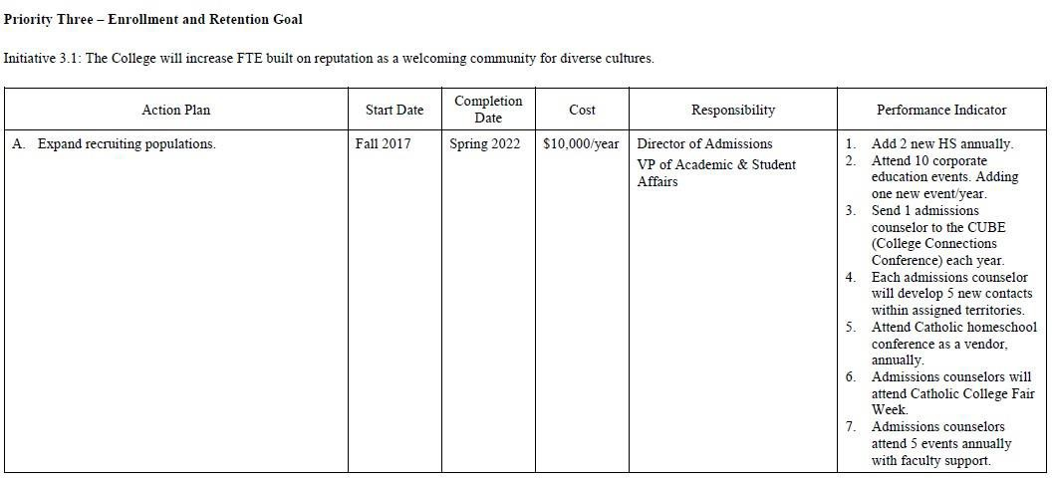
Year 1 Updates
Spring 2018:
- Missouri HS added in Fall 2017: Staley, Oak Park, Winnetonka, Grandview, Lee’s Summit, Truman, William Chrisman, Belton, and Horizons (alternative school).
- Attended corporate events at Garmin, UPS, KU Healthcare System, City of Leawood, City of Overland Park, Best of the Best, KCK.
- Amber Taylor attended the conference in October 2017.
- Developed new point of contacts with high school teachers and guidance counselors.
- Cicely Bledsoe attended the conference in June 2017.
- All Admissions Counselors participated in the week-long Catholic College Fair held at respective Catholic HS, October 2017.
- Admissions Counselors invited Gayle Lee, Ana Maradiaga, and Ana Valdez to recruiting events in Spring 2018.

Year 2 Updates:
Spring 2019:
- Kansas-Added Blue Valley North and Blue Valley Northwest HS and Lansing, KS. Missouri-Liberty HS.
- Attended Clinical Reference Laboratory, KCKPS, KU Med-Fairway, KCK, and Westwood, Harvesters, Nebraska Furniture Mart, Community America Credit Union, Garmin, City of Overland Park, City of Leawood.
- Amber Taylor, Admissions Counselor, attended CUBE August 31, 2018.
  - Admission Counselors made contacts with counselors and teachers at new high schools added. Increased contacts at Sumner HS in KCKPS and KCMO districts.
  - Conflict with Catholic Home school conference-did not attend.
  - Admission counselors attended Catholic College Fair Week on September 11-13, 2018.
  - MCC and KCKCC Transfer Fair had faculty support: Ana Valdez, Ana Maradiaga, Gayle Lee. Attended STEM Fair: Laura McKnight and Ana Maradiaga. Ana aldez attended Manual Career Tech Coding Event.
  - Parent Information Night supported by Gretchen Meinhardt and Melissa Lenos.

Year 3 Updates:
Spring, 2020:
- Added 1 High School to our Territory List: Horizon's Academy.
- Corporate events attended:
  - KC Metro Expo Fair Sept. 16 b. UPS Lenexa Fair Sept. 25
  - UPS KCK Fair Sept. 26
  - Best of KCK Chamber Expo Oct. 8 e. Synchrony Financial Nov. 6
  - Public Service Career Expo Nov. 7 g. Centrinex Adult Ed Fair Nov. 7
  - HDF Bilingual Tour participant Dec. 12 i. KCCAP Fair- KU Med Feb. 17
  - 2020 Leadership Fair March 6
- Presented at CUBE. All of our counselors attended the event this past year.
- Counselor attended the Kansas City Catholic College Week

Year 4 Updates
Spring 2021:
- Add (2) two new high schools annually - Journey School of Choice; rebuilt relationship with Bishop Ward High School
- Attend ten (10) corporate education events, adding one (1) new event per year - Due to COVID restrictions, the organization we partner with for the majority of our corporate education events (Kansas City Consortium of Admissions Professionals/KCCAP) was unable to schedule any events. - We did add two new events this year: Eighth Street Baptist Church and KC Youth Conference (Catholic schools in the greater Kansas City area).
- Send one (1) admissions counselor to the CUBE (College Connections Conference) each year - Virtual Event on September 2, 2020
- Each admissions counselor will develop five (5) new contacts within their assigned territories - Once again, COVID greatly restricted this process. In addition, there has been considerable turnover in the Admissions Department. Beginning December 2020 to June 2021, the Admissions Team is completely new from the team who started the fiscal year in July 2020. They are tasked at this time with building relationships with the current high school counselors and contacts in their territories. Once the team is better established, there will be opportunity for expansion.
- Attend Catholic Homeschool conference as a vendor annually - Attended Virtually
- Admissions Counselors will attend Catholic College Fair Week - Attended Virtually
- Admissions Counselors will attend five (5) events annually with faculty support - Due to COVID restrictions, this did not occur.

Year 5 Updates
Spring 2022:

- The Admissions Department had an average of two (2) Admissions Counselors for 2021-2022. If calculated at 20 high school visits per semester/40 per year, that would equate to 80 high school visits.
- The Admissions Team attended 103 standard high school visits.
- Each Admissions Counselor will attend a minimum of five (5) College Fairs (total of 10)
- The Admissions Team attended twenty (20) College Fairs
- The Admissions Team attended eight (8) College/Community College Events
- The Admissions Team will attend CUBE each year
- Attended 9/2/21

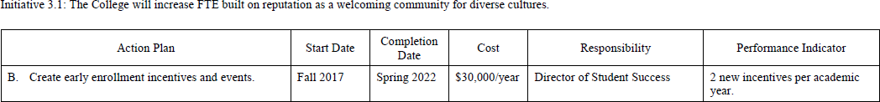

Year 1 Updates:
Spring 2018:
- T-Shirt incentive for students that pre-enroll for Fall 2018.
- Tuition incentive for students that enroll in more than 12-credit hours. The first 12- credit hours are at regular rate; 13-15 credit hours are at half tuition rate and no fees.

Year 2 Updates:
Spring 2019:
- Book vouchers were awarded to students (lottery) who enrolled early for the spring, 2019 semester.

Year 3 Updates:
Spring 2020

- Continued tuition incentive for students that enroll in more than 12 credit hours.
- Students who enrolled by the end of finals week were entered into a drawing for VISA gift cards.

Year 4 Updates
Spring 2021:

- Continued tuition incentive for students enrolled in more than 12 credit hours per semester.
- After assessing the enrollment of returning students, it was determined that incentives were no longer needed for returning students. Advisors set up meetings with all their students prior to summer break to ensure students were enrolled in the fall semester.

Year 5 Updates
Spring 2022:

MET
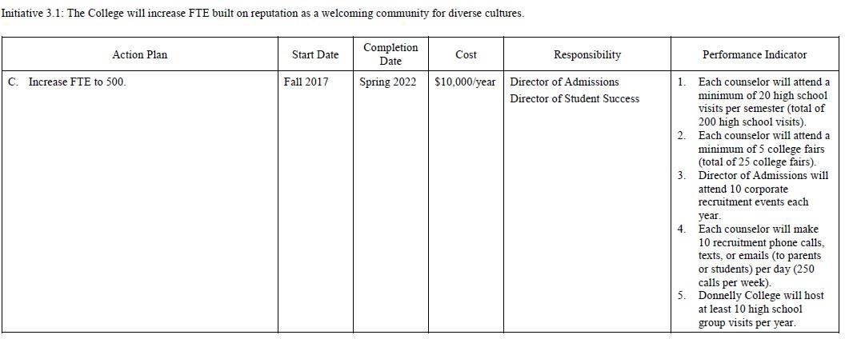
Year 1 Updates:
Spring 2018:
  - Admissions Counselors made an average of 22.5 visits per semester. This will increase to 25 visits per semester in Fall 2018.
  - Attended MCC Transfer Fair, KC Scholars, East/Northeast College Fair, and Junior Achievement.
  - Director of Admissions attended 6 corporate events.
  - Admissions Counselors used Donnelly College-owned cell phones to text students, call and send e- mails daily.
  - Fairfax, JC Harmon, Alta Vista, and Olathe Schools visited Donnelly College. For Fall 2018, high school visits will be scheduled over the summer, so that students may meet the March 1 scholarship deadline.

Year 2 Updates:
Spring 2019:
  - Admissions Counselors attended 25 HS visits in fall, 2018.
  - Each counselor attended KC Scholars, KCKPS Senior Fair, Turner HS, Shawnee Mission HS and KCMO at UMKC.
  - Estevan Ortiz, Director of Admissions attended 10 corporate recruitment events in 2018 through KCCAP: Garmin, KUMED, Harvesters, Nebraska Furniture Mart, City of Overland Park, City of Lenexa, KCKPS, BPU and Community America Credit Union.
  - Each counselor has their own Donnelly cell phone and makes texts, calls and sends emails to students daily.
  - Donnelly College hosted the following high school groups: Bishop Ward HS with HDF, Turner HS,
J.C. Harmon HS, St. James High School, Cornerstones of Care, Carthage, MO HS, Olathe School District, F.L. Schlagle HS and Wyandotte, HS and Alta Vista HS
Year 3 Updates:
Spring, 2020
  - Admissions Counselors attended 89 HS visits in fall, 2019
  - Admissions Counselors attended 27 College Fairs
  - Both Director of Admissions and Admissions Counselor attended 7 Corporate Fairs in Fall, 2019.
  - Each counselor has their own Donnelly cell phone and makes texts, calls and sends emails to students daily. While this data cannot be tracked for enrollment trends, the office of the EMO has purchased a data software package for texting and phone call tracking purposes, called Cadence by Mongoose Research.
  - Donnelly College hosted the following high school groups: Olathe North, Turner HS,
J.C. Harmon HS, Cristo Rey, Prep KC, Sumner HS, Horizons, HDF Bilingual Tour, and Alta Vista HS.

Year 4 Updates
Spring 2021:
  - With three (3) counselors x two (2) semesters per year, realistically that is 120 high school visits - During COVID restrictions, both Kansas City Missouri and Kansas City Kansas Public School Districts experienced a 50%+ truancy rate. This provided quite the challenge to the Admissions Team. Considering those facts, the team still conducted 114 high school events for fiscal year 20-21. (See attached Event Schedule)
  - Each counselor will attend a minimum of five (5) college fairs (total of 25 college fairs) - The team conducted ten (10) said events - All but one (1) was virtual
  - Director of Admissions will attend ten (10) corporate recruitment events each year - Again, due to COVID restrictions, this was difficult to complete and the director is looking forward to those opportunities for 21-22. Here are the events the director did attend:
  - Rebuilt a positive relationship with Bishop Ward High School - brought five (5) students on campus Spring 2021 semester for the College Credit Now Program. These numbers are set to increase for Spring 2022.
  - MOU with Ottawa University - from inception through signing.
  - Building a working relationship with Latinx
  - Participated in a COVID conference with KLC
  - Met with Kansas City Kansas Community College to promote successful implementation of the MOU
  - Asked by NEPRIS to be a community mentor - spoke to 4th graders in the Hickman Mills School District on “The Importance of Goal Setting”
  - Met with Metropolitan Community College to promote successful implementation of the MOU
  - Organized and conducted three (3) Hispanic Development Fund events on campus with Guadalupe Centers and East High School
  - Organized and conducted a community ACT Prep test in conjunction with Open Future
  - Each counselor will make ten (10) recruitment phone calls, texts, or emails (to
  - parents or students per day (250 calls per week) With the addition of the Mongoose/Cadence system), the Cadence related texts and emails could be traced. At 210 per week x
  - 52 weeks, the expectation is 10,920. The Cadence numbers indicate 7,723 texts
  - and/or emails for fiscal year 20-21. This number does not include other phone calls
  - (Incoming and outgoing) or emails that are not tied to Cadence which are not able to
  - be tracked.
  - Donnelly College will host at least ten (10) high school group visits per year - Virtually
  - the team conducted four (4) Virtual Information Sessions where all high schools were
  - invited, two (2) FAFSA Information Nights where all high schools were invited, plus
  - three (3) on campus tours and one (1) virtual tour.

Year 5 Updates
Spring 2022:

- Director of Admissions will attend ten (10) corporate recruitment events per year
- With KCCAP not yet being operational and providing corporate table sits. The Director did
- attend seventeen (17) events, including multiple KCCAP meetings. The Director has also continued to build the relationship between Bishop Ward, MCC, KCKCC and id also working closely with Wyandotte and Sumner and The Hispanic Development Fund. The Director was instrumental in several big events on campus including but not limited to the Presidents, Principals, and Counselors event and the High School Counselor Luncheon. Currently working on promoting relationships with UPS, FedEx, Migrant Farm Workers, St. Paul’s Catholic Church, and Gear Up The Director is also responsible for integrating Common App to Donnelly College to increase FTE.
- Each Admissions Counselor will make ten (10) recruitment calls, texts, or emails to students and/or
- Parents per day (100 per week/5,200 annually)
- Mongoose/Cadence reporting shows that the Admissions Team sent 8,062 texts/emails from 7/1/21 through 6/26/22. That would average out to 155 per week. This number does not
- Include the phone calls and emails sent from their desktops/laptops. They are exceeding
- Outreach expectations.
- Donnelly College Admissions Team will host at least ten (10) high school group visits per year.
- The Admissions Team hosted twenty (20) on campus group visits.
- Each Admissions Counselor will develop five (5) new contacts within assigned territories. (14)
- KC Private High Schools, KC Metro College Expo, Olathe Alternative, Journey
- School of Choice, Suburban Balance, Central Academy of Excellence, Frontier STEM,
- Raytown Success Academy, Urban Youth Academy, Gloria Willis Middle School, EWH
- Elementary, Central Middle School, Argentine Middle School, Chesterton Academy,
- and St. Paul’s Catholic Church

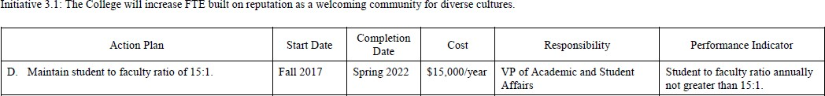

Year 1 Updates:
Spring 2018:

  - The Student/Faculty ratio for AY 17-18 was 10:1

Year 2 Updates:
Spring 2019:

  - The Student/Faculty ratio for AY 18-19 was 11:1

Year 3 Updates:
Spring 2020
- For the fall enrollment IPEDS report, our current student to faculty ratio is 11:1 which is below the projected 15:1. Donnelly College strives to align the mission with providing personalized instruction to our students to maximize the learning experience.

Year 4 Updates
Spring 2021:
- For the fall enrollment IPEDS report, our current student to faculty ratio is 10:1

Year 5 Updates
Spring 2022:
- Ratio for AY 21-22 was 10:1

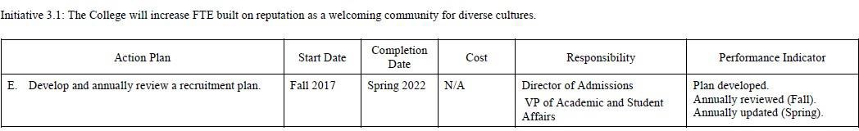

Year 1 Updates:
Spring 2018:
  - Plan developed and implemented.
  - Recruitment Team met with the Interim AVPASA in April 2018 to review strategies and goals to update the plan.

Year 2 Updates:
Spring 2019:
  - Recruitment Plan was updated in March 2019.

Year 3 Updates:
Spring 2020
- With the help of our new Enrollment Management Office a Recruitment Plan was developed.

Year 4 Updates
Spring 2021:
  - This is a living recruitment plan that is updated as needed. For 2021-2022, the Director is implementing a focus on the parents of high school students. The Inquiry Card has been updated to be more useful to the recruitment process and include parent information. (attached). The Director has also developed two “slicks” to be
  - shared with parents: A Smart Choice for Families - Local/Affordable/Diverse/Catholic and A Smart Choice for Families Checklist (both attached) to supplement the campaign. The website was updated with a Spanish version of the Admissions page. The Acceptance Letter was updated to include one side in English and the other side in Spanish. (Attached) The Director also created: Success Starts Here - Transfer Guide to Donnelly College to aid counselors in recruitment at community college fairs. The website was also reorganized to have two links - one for students wishing to transfer into Donnelly College and the other for those wanting to transfer to other schools once they have their associates degree from Donnelly College. Prior there was only a link showing students how to leave Donnelly, not come to Donnelly. Finally, the director also created two marketing pieces - a Donnelly Dragon outreach postcard with Donnelly stickers and a “Good News Inside” envelope. All of these were created to promote Donnelly College and enhance the established Recruitment Plan.

Year 5 Updates
Spring 2022:
- Develop and annually review a recruitment plan
- Reviewed, updated, and submitted on June 1, 2022, to Institutional Effectiveness Officer

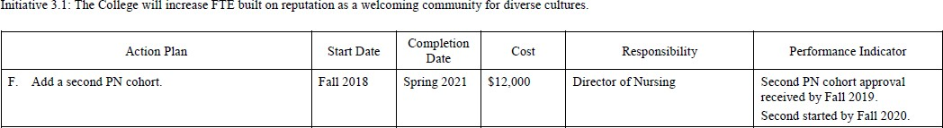

Year 1 Updates:
Spring 2018:

  - Director of Nursing preparing documentation to the Kansas Board of Nursing.
  - Donnelly’s PN Program received re-accreditation from the Kansas Board of Nursing in June 2018, following a site visit in April 2018.

Year 2 Updates:
Spring 2019:
  - Second PN cohort approval received by Fall 2019. Second started by Fall 2020.
  - The second cohort of PN students was approved by the KSBN.

Year 3 Updates:
Spring 2020
- Due to the COVID-19 crisis, all KSBN Board meetings were cancelled. We won’t be able to go to the board to ask for the second cohort until September of 20, 2020.
- That second cohort, if approved, would start in Spring of 2021.

Year 4 Updates
Spring 2021:

- A second PN cohort was requested in the Spring of 2021 and approved by KSBN (delay due to COVID shut down). Daytime PN cohort starts with nursing classes to begin Fall 2021. (Attachment of approval from KS State Board of Nursing

Year 5 Updates
Spring 2022:

- MET

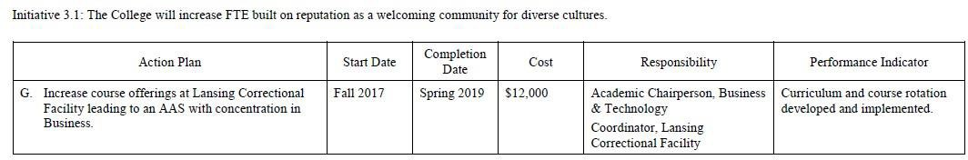

Year 1 Updates:
Spring 2018:

  - Due to the redirection of focus on the HLC directives, the AAS courses have not been identified to date. With the completion of deliverables for HLC and the subsequent visit the planning for this initiative will begin in AY 18-19.

Year 2 Updates:
Spring 2019:

  - Susan Lechliter, Coordinator, is working with Richard Wallace, Director of Baccalaureate Programs, to evaluate the rotation of courses offered in the AAS Business degree program.

Year 3 Updates

Spring 2020:
- Our course offerings and Associate degree Program at Lansing received an enormous honor in spring 2020 when we were chosen to receive the PELL ESI grant. This grant awards Pell grants to incarcerated students so that they may start or complete their college education. The Experimental Sites Initiative will allow our Lansing students to take 12 CR HRS if they are full Pell eligible. We will expand this program to include the Associate of Arts degree as well.

Year 4 Updates
Spring 2021:
- Associate degrees at Lansing CF are offered for both Pell and non-Pell eligible students.

Year 5 Updates
Spring 2022:

- No updates
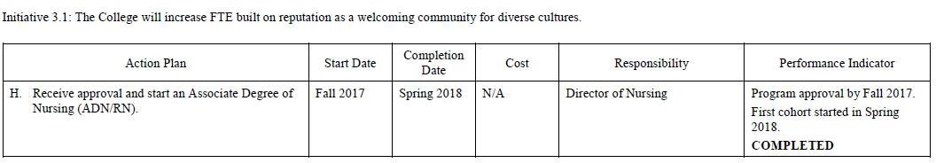

Year 1 Updates
Spring 2018:
  - Program approved by the Kansas Board on Nursing (KSBN) on 12/13/16.
  - KSBN approved the first cohort to a maximum of 15 students.
  - Some adjustments to the curriculum had to be made and was completed during Spring and Fall of 2017.
  - First cohort started in Spring 2018 with 15 students.

Year 2 Updates
Spring 2019:

  - The 8/16 site visit by KSBN approved the ADN program to admit 15 students per year with a follow- up site visit to occur after the first graduation.

Year 3 Updates

Spring 2020:
- KSBN approved the program in December of 2016, The first Cohort was -from Jan 18- May 19 and second cohort was 1/19-5/20. We are on conditional approval as of 5/20 and have asked for a change in the starting semester to be August 2020 while changes were made to the RN program to correct low NCLEX scores and formulate missing protocols and items for KSBN. Pending Board approval in September 2020, the LPN program has been recommended for the next five years and the ADN for a January 2021 start date.

Year 4 Updates

Spring 2021:

Met

Year 5 Updates

Spring 2022:

Met

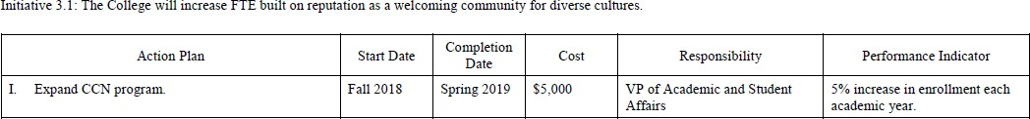

Year 1 Updates
Spring 2018:

  - In Progress

Year 2 Updates
Spring 2019:
  - Working with USD500 on career pathways for students in high school. Tara Lindhal, JC Harmon HS is the lead coordinator for Business and IT CCN pathways and CNA pathways. Meetings started in fall, 18-present.

Year 3 Updates

Spring 2020:
- In Fall 2019 several CCN students migrated to a neighboring College Credit Now program as they were offering adjuncts on HS campuses. The CCN handbook has been updated and this will be a focus for the Coordinator of ASA.

Year 4 Updates

Spring 2021:
MET

Year 5 Updates
Spring 2022

- The CCN continues to grow in offerings to local high schools with the addition of Bishop Ward students in the 21-22 AY. When Donnelly was approved for distance learning in SP21, a discussion began to build a partnership with schools offering CCN in an online format. Our first iteration of this offering will take place in FA22 with Christian Halls Inc. home-schoolers.

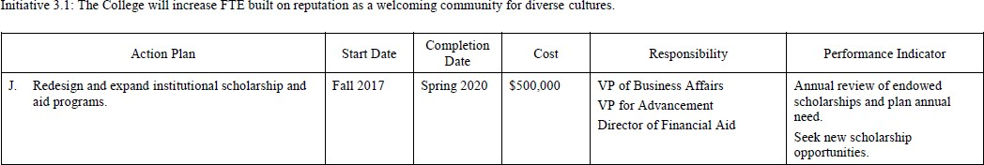

Year 1 Updates
Spring 2018:

  - Reviewed current scholarship offerings and revised publications of scholarship information.

Year 2 Updates
Spring 2019:

  - Replaced ending CAMP grant scholarship with MAP institutional scholarship for Migrant students.

Year 3 Updates

Spring 2020:

- Redesigned student scholarship page on website and created handouts to represent the new scholarship offerings and guaranteed merit program.

Year 4 Updates
Spring 2021:

No updates

Year 5 Updates
Spring 2022:

- Changed awarding of Donnelly endowed scholarships to be the last amount applied after all other government grants, loans, and outside scholarships.

- Redesigned and expanded scholarship program
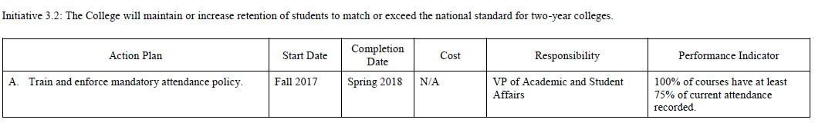

Year 1 Updates
Spring 2018:

  - 100% of courses have at least 75% of current attendance recorded.

Year 2 Updates
Spring 2019:
  - Attendance increased to 85% for fall, 18 courses.

Year 3 Updates
Spring 2020:
- Only 84% of classes had 85% or more of their attendance recorded.

Year 4 Updates
Spring 2021:

- 97% of classes had 75% or more of their attendance recorded

Year 5 Updates
Spring 2022:

- 99% of scheduled classes had 75% or more of their attendance recorded

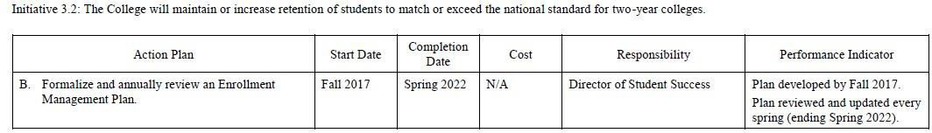

Year 1 Updates
Spring 2018:

  - Plan developed and in implementation.

Year 2 Updates
Spring 2019:

  - Enrollment Management Plan was updated in March 2019. Increased retention rate to 64%.

Year 3 Updates

Spring 2020:
- Director of Student Affairs and Enrollment Management Officer met to review the Enrollment Management Plan. Upon review, we decided to create two documents, a Recruitment Plan and a Retention Plan. By separating the document, we were better able to focus on the distinct aspects of each plan and assess their interdependence.

Year 4 Updates
Spring 2021:
- Last year, the Enrollment Management Plan was divided into two plans: a Recruitment Plan and a Retention Plan. Each plan was reviewed and updated at the end of the Spring semester.

Year 5 Updates
Spring 2022:

MET

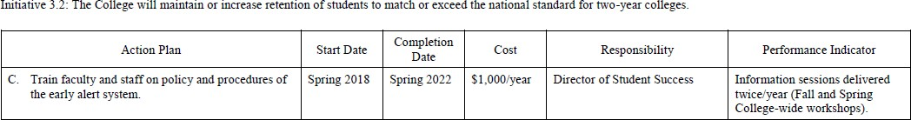

Year 1 Updates
Spring 2018:

  - Information sessions delivered twice/year (Fall and Spring College-wide workshops.)

Year 2 Updates
Spring 2019:
  - Early alert workshop offered bi-annually for all staff.

Year 3 Updates

Spring 2020:
- Director of Student Affairs and Enrollment Management Officer met to review the Enrollment Management Plan. Upon review, we decided to create two documents, a Recruitment Plan, and a Retention Plan. By separating the document, we were better able to focus on the distinct aspects of each plan and assess their interdependence.

Year 4 Updates
Spring 2021:

- The Early Alert System has been changed to Academic Alert.
- Faculty and Staff were trained in utilizing the system at Fall and Spring workshops.
- The advising team met to develop a plan to better close the loop on follow-ups. Advisors will inform the faculty or staff member regarding follow-up information.
- LAS Faculty received at the beginning of Fall 2020 and Spring 2021 an email reminding and explaining them the use of Early Alert (and the link to submit a report).

Year 5 Updates
Spring 2022:

No updates

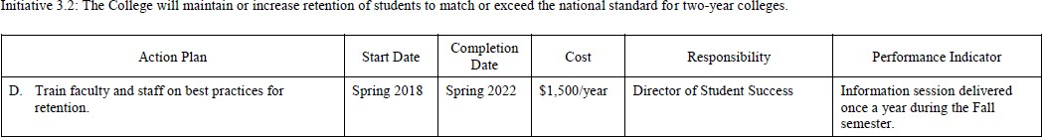

Year 1 Updates
Spring 2018:

  - Information session planned for Fall, 2018 implementation at a community meeting.

Year 2 Updates
Spring 2019:

  - Presented "TIME is the enemy" to faculty and staff in spring, 2019. Presentation on increased retention of students. Presented by Advisor, Megan Jordan.

Year 3 Updates
Spring 2020:

- Student Support Services department presented at the community meeting in Fall ’19 highlighting how each area provides student support, with an emphasis on integrating faculty in the classroom.

Year 4 Updates
Spring 2021:
- Student Support Services presented at the Fall and Spring faculty/staff workshops.
- Per SEM recommendations, LAS faculty were encouraged to reach out to their students the week before classes started to encourage them to start strong and be ready to hit the ground running.

Year 5 Updates
Spring 2022:

No updates

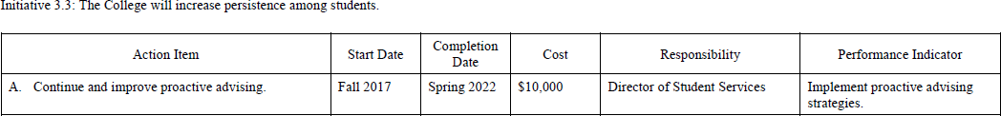

Year 1 Updates
Spring 2018:

  - Academic Advisors members of Kansas Academic Advising Network (KAAN).
  - Attendance at regional/national conferences for the Global Community for Academic Advising conferences.
  - Implementation of proactive advising strategies (reaching out to the student before an early alert is posted).

Year 2 Updates
Spring 2019:

  - Implement proactive advising strategies.

Year 3 Updates
Spring 2020

- Emphasize completion of student success plans identifying goals and strategies.

Year 4 Updates
Spring 2021:

- Advisors updated Student Success Plans for new and returning students.
- The advising team implemented a new texting service, Cadence, to connect with students more effectively.

Year 5 Updates
Spring 2022:

- No updates

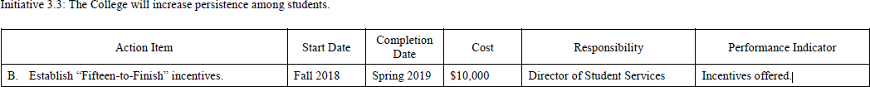

Year 1 Updates
Spring 2018:

  - For AY 18-19, students enrolled in more than 12-credit hours will be charged half- tuition for the hours over 12.

Year 2 Updates
Spring 2019:

  - For AY 19-20 students enrolled in more than 12-credit hours will be charged half tuition for the hours over 12.

Year 3 Updates
Spring 2020:
- There were no changes to the existing incentive; advertise more broadly to increase student awareness.

Year 4 Updates
Spring 2021:

- There were no changes to the existing incentive; advisors and admissions counselors continue to make sure students are aware of this incentive.

Year 5 Updates
Spring 2022:

- No updates

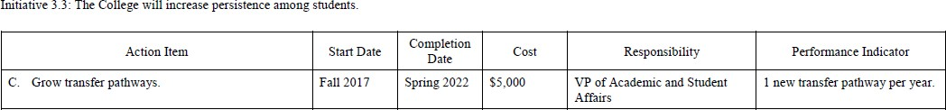

Year 1 Updates
Spring 2018:

  - Transfer agreements established with Emporia State University and Metropolitan Community College

Year 2 Updates

Spring 2019:

  - Signed transfer pathway with University of St. Mary in May 2019.

Year 3 Updates

Spring 2020:

- This year, Donnelly signed articulation agreements with Kansas City Kansas Community College and the University of St. Mary. Both agreements form a pathway for incoming bachelor’s degree students and graduating Associate degree students.

Year 4 Updates
Spring 2021:
- This year, Donnelly signed articulation agreements with both Ottawa University and Metropolitan Community College. The Ottawa agreement allows for a pathway between Donnelly’s AA program into Ottawa’s BA program, and the MCCC allows for a pathway between MCCC’S AA program into Donnelly’s BA/BS program.

Year 5 Updates
Spring 2022:

- No updates
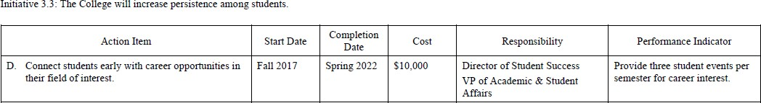

Year 1 Updates
Spring 2018:

  - Mock Interviews held in Fall, 2018 and Spring, 2018
  - Career Fair held in April 2018.
  - Students completed Career Cruising in CCS 101 course.
  - Success Navigator completed at Orientation sessions.
  - Students complete individual Success Plans to target strengths and weaknesses.

Year 2 Updates
Spring 2019:

  - Held Mock Interviews, the annual Career Fair in Spring, 2019.
  - Students completed Individual Success Plans in Advising to target strengths and weaknesses.
  - Students completed Career Cruising in CCS101 course.

Year 3 Updates
Spring 2020:

- Continued practices from Years 1&2 (Mock Interviews, Individual Success Plans, and Career Cruising).
- The Associate Director of Academic Support worked quickly to move Career Day virtual due to Covid-19.
- A virtual career day was held on May 14, 2020, in response to the COVID-19 crisis.

Year 4 Updates
Spring 2021:

- Career Services continued to provide resume workshops, mock interviews, career fair, and individual appointments for students.
- Career awareness was more visible in the curriculum of the First Year Experience course.

Year 5 Updates
Spring 2022:

- No updates

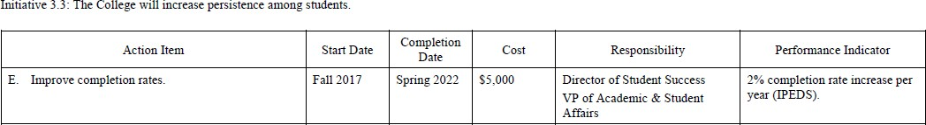

Year 1 Updates
Spring 2018:

  - Analyzing data. The 9% increase is based on the 2009 full-time, first time freshman.

Year 2 Updates
Spring 2019:

  - Analyzing data from IPEDS. The 19% is an increase from the previous rate of 9%.

Year 3 Updates
Spring 2020:

- According to the reported 2019-2020 IPEDS data, our persistence to graduation rate has dropped from 19% to 17%.

Year 4 Updates
Spring 2021:

- No change in the persistence to graduation rate (13%)
- We have been accepted into the HLC Student Success Academy to improve our rates.

Year 5 Updates
Spring 2022:

- Student Success Academy established focus areas particular to improving retention

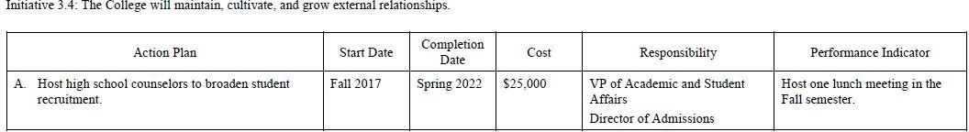

Year 1 Updates
Spring 2018:

  - HS Counselors Luncheon was held in Fall 2017, at this luncheon each Counselor was awarded a scholarship to bring back to their school.
  - DC Admissions Counselors will select a date for Fall 2018. “Save the date” cards will be sent to HS Counselors in Summer 2018.

Year 2 Updates
Spring 2019:

  - High School Counselor luncheon was held on October 3, 2018 at the Event Center. High School Counselors from feeder schools were invited to attend.

Year 3 Updates

Spring 2020:
- A high school Counselor luncheon was held in January 2020. In the spring, Donnelly swag baskets were prepared for each HS Counselor. Due to the COVID-19 crisis the delivery of these baskets has been delayed.

Year 4 Updates
Spring 2021:

- Due to COVID-19, there was limited contact (emails/phone calls only) with high school counselors.

Year 5 Updates
Spring 2022:

- Delivered treat boxes to counselors August and September of 2021
- Hosted High School Counselor Luncheon on March 28, 2022

Initiative 3.4 The College will maintain, cultivate, and grow external relationships.

Action Plan | Start Date | Completion Date | Cost | Responsibility | Performance Indicator
B. Foster community, church, and business leaders to provide internships, service-learning  projects | Fall 2018 | Spring 2022 | $1000/year | Academic Program Directors | AY 18-19 3 Projects  AY19-20 3 Projects  AY20-21-4 Projects  AY21-22-5 Projects

Year 1 Updates
Spring 2018:
- HS Counselors Luncheon was held in Fall 2017. At this luncheon, each Counselor was awarded a scholarship for a student at their respective high schools.
- Career Services has formed partnerships with Community leaders to form internship opportunities.

Year 2 Updates
Spring 2019:
- Relationship with Unbound cultivated to include civic engagement projects from CCS097, CCS040 and EN111 in Spring 2019.
- Relationship with University of St. Mary cultivated to expand transfer pathways.
- Relationship with American Public Square Talks to collaborate on Common Read author event in fall 2019.

Year 3 Updates
Spring 2020:
- On November 25, 2019, a Pastor's breakfast was held for all area faith Pastors. At the breakfast, each Pastor was presented with an opportunity to award one of their parishioners with a Donnelly scholarship.
- Our initial steps of partnering with local EPA branch has resulted in a pending MOA. They have provided internship opportunities for our students in the STEM fields.
- The students in the Success First program were able to answer sponsor letters for the Unbound Organization. The students increased their written communication while providing a civic service to this organization.

Year 4 Updates
Spring 2021:
- August 2020 Paula Console-Soican worked with El Centro to formalize the Job Training Program that they started two years before under the tutelage of Richard Mabion, and which concluded with the EPA grant received by El Centro and their partners in 2019. For more, see here https://www.epa.gov/newsreleases/mayors-kck-and-kcmo- announce-job-training-initiatives-epa The start of the program was delayed due to COVID restrictions.
- On September 21, 2020, Donnelly College and EPA Region 7 signed an MOU.
- Paula Console-Soican, English professor and a student team submitted a demonstration project proposal “A Garden for Everyone” for the 2020 EPA Campus RainWorks Challenge, a green infrastructure design challenge for Colleges and Universities.
- Spring 2021 LAS faculty have fostered relationships with the Sierra Club through Richard Mabion, with the Marais des Cygnes National Wildlife Refuge Visitor Services Manager to coordinate service-learning visits for the Environmental Science course and met with J.C. Harmon High School Science Educator, David Bennett, to study the possibility on collaborating in a Compost and Food Waste Reduction project.

- The Donnelly College ADN and PN nursing classes worked with the Unified Government on the COVID-19 Vaccination of Wyandotte County by taking all weekends in May and June and giving vaccinations at the Armory location in Wyandotte County. (Attachment of acknowledgement from Wyandotte County COVID-19 Vaccine Operations Director). The nursing classes also held vaccination clinics at Donnelly College as well during the week for students, faculty, and their families

Year 5 Updates
Spring 2022:

- Day of Service held the Saturday before classes start. Locations include:
Turnstyles Thrift Store
Sanctuary of Hope
St. Paul’s Episcopal Church
Bridging the Gap
Crosslines
KCK Housing Authority/Community Garden

Initiative 3.4 The College will maintain, cultivate, and grow external relationships.
Action Plan | Start Date | Completion Date | Cost | Responsibility | Performance Indicator
C. Develop alumni and donors for institutional support. | Fall 2018 | Spring 2022 | $10,000/yea r | VP for Advancement | Revise and execute Stewardship Plan

Year 1 Updates
Spring 2018:

  - No update

Year 2 Updates
Spring 2019:

  - Engaged Gonser Gerber during the 2018-19 to assist in preparation of long-term fundraising plan.

Year 3 Updates

Spring 2020:

- Several projects were completed in Year 3, 2019-2020 to develop alumni, donors to grow institutional support. Donnelly completed the first year of 3-year consulting contract (which began May 2019) with Gonser Gerber to grow the overall advancement program, and the projects below all benefitted from that guidance. (In addition to working with the Advancement Office, the board, and the president, Gonser Gerber is also providing other higher ed consulting to Donnelly across many areas, although primarily Advancement and Admissions.)
- Re-designed direct mail annual strategy this year, which quadrupled the size of our annual mailed Holiday appeal and committed to an annual Spring appeal of the same segments. The mailing list now includes all individual donors who had not yet given this fiscal year and segmenting those into five donor categories, each with a customized message in the appeal. The re-designed strategy calls for three mailings each year to these same segments: SHINE appeal in Aug/Sept, Holiday Appeal in Dec, Spring Appeal in May. (Cost increased by ~$5,000/mailing or $10,000 total.) The Holiday Appeal Thank you letter was separately designed to reflect additional stewardship touch and continue alumni feature from the appeal letter. See evidence for segments, letter samples and appeal performance summary.
- Created a new event to engage alumni and donors, as well as current students/future alumni: 1Day4Donnelly. Held for the first time on March 4, 2020, the new event raised $23,470, from 52 donors, 21% who were first-time donors and 46% were lapsed donors. In addition, faculty and staff volunteered to call alumni, A poster highlighting philanthropy impact was displayed (and kept out through the remaining semester), 107 students participated in thanking donors throughout the day, and there were 2,600 Facebook/social media engagements and views. The event was successful and has been integrated into Advancement’s Annual Fundraising plan to be always held on the first Wednesday of March, scheduled next for March 3, 2021. There is a standing 1Day4Donnelly page on Donnelly’s website highlighting 2020 photos and with a countdown clock to the 2021 event. See evidence for the Performance Summary and event materials.
- Exceeded Annual Fund goal - Our Annual Fund goal for FY2019-20 was $1,425,920. Advancement
50

exceeded that goal by 10%, securing $1,572,675. $146,755 above the goal. An additional $135,300 was secured for new unbudgeted 19-20 institutional projects.
- In the midst of the Covid-19 pandemic, the Advancement division also helped to secure several CARES Act federal grants to meet expenses related to adapting operations in response to the pandemic. As of June 30, 2020, three grants totaling $313,515 were secured, a fourth application (totaling $186,000) was still pending, and a fifth application (totaling almost $190,000) was under preparation to be submitted in July 2020. Two private grants totaling $65,000 were also secured by June 30.
- Prospect Management Improved – Constituent database was restructured to code, track and report prospects’ status and prospect classification. A new manual was created to train staff and ensure consistent database tracking/reporting of major donor and Annual Fund Leadership donor prospects and their cultivation status. Weekly Fundraising team meetings with the VP of Advancement, Constituent Database Analyst, Annual Fund coordinator and Major Gifts Officer were held to train staff on data entry and monitor prospect moves management. See evidence for Prospect Management Plan and the June 30, 2020 Major Gift Prospect report.
- Stewardship Plan revisions were begun in 2019-20 and will be completed in 2020-21. The expanded plan aims to address a unique stewardship strategy for every type of donor to the College, including annual fund, annual fund leader, major, capital, endowed and planned gift donors). The Annual Fund Leader stewardship strategy was outlined by December 2019, resulting in the new Jerome Society. New member recruitment began by the Annual Fund Officer in January 2020 and branding/collatoral materials (including its own page on Donnelly’s website) were completed by March 2020. The Inaugural Jerome Society Member Newsletter was in development in June 2020 and is scheduled to be mailed to members in Aug 2020. See evidence for the Jerome Society brochure and promotion in the Summer 2020 Donnelly Digest.
- Board Retreat – The board held its first retreat in nearly 10 years in August 2019. The focus was strategic planning to increase institutional stability, as well as a discussion philanthropy’s role in achieving goals and the board’s role in philanthropy. See evidence for agenda, minutes, presentation, and post-retreat evaluation.
- Improved Donor Retention – In combination with the above activities, Advancement is also beginning to more closely monitor donor retention. Using a free, formatted “Fundraising Fitness Test” made available by The Fundraising Effectiveness Project website, which is a collaborative project of the Association of Fundraising Professions Foundation for Philanthropy. (www.afpfep.org/tools). Donnelly’s reports comparing FY 2018 vs FY 2019, and FY 2019 vs FY2020 are attached. Overall donor retention increased from 45% to 50%. Repeat donor retention increased from 53% to 66%.

Year 4 Updates
Spring 2021:

None

Year 5 Updates
Spring 2022:

- Donnelly completed the third year of 3-year consulting contract (which began May 2019) with Gonser Gerber to grow the overall advancement program, and the projects below all benefitted from that guidance. Donnelly extended the contract with Gonser Gerber for another year.
- Direct mail annual strategy was changed slightly from year four. While we continued to send to a larger group for our Holiday Appeal, the End of Year Appeal was dropped in year five. For the Holiday Appeal we used a card rather than a letter. The card had a student story and included a response portion and a QR code which linked to both a video of the student story and also linked to an online give page. The Holiday Appeal had a similar 1% response rate to the previous year and we picked up 4 donors who had not previously given. We did not do an End of Year appeal. See evidence for card samples and appeal performance summary.

- Continued the success of 1Day4Donnelly. This year the event, held on March 9, 2022, raised nearly $48,000 – an increase of 37% over the previous year. Fourteen faculty and staff volunteered to call 275 alumni. A poster highlighting philanthropy impact was displayed the day of the event and through the
- remaining semester. Students participated in thanking donors throughout the day by writing thank you cards and filming personalized thank you videos sent to donors via email. There were 1,245 Facebook/social media engagements and views. There is a standing 1Day4Donnelly page on Donnelly’s website highlighting 2022 photos and with a countdown clock to the 2023 event. See evidence for the Performance Summary and event materials.
- Met Annual Fund goal - Our Annual Fund goal for FY2021-22 was $1,390,000. Advancement raised $1,475,476 or 106% of the goal and an additional $25,000 was secured for new unbudgeted 21-22 institutional projects. SHINE, our annual Scholarship Dinner was changed to a virtual event and set a record with nearly $720,000 raised. We added a Major Gift Officer position in January, 2022 which has helped in our efforts cultivate our major gift (gifts of $5,000 per year for 5 years) prospects. See evidence for SHINE materials and Year End report.
- Jerome Society membership – recognizing those individuals who have made Annual Fund gifts of $1,000 or more in a calendar year. Jerome Society member names were etched into bricks that were installed in the patio area of the new campus quad. We currently have 122 Jerome Society members, which includes 26 new and 96 renewing members.
- Donor Retention – Overall donor retention is at 53% which is a slight decrease from last year, but still ahead of national averages. New donor retention is 25% which is a slight decrease from last year, but over 6% higher than the national average. Repeat donor retention was 63% which, again, is a slight decrease from last year but still above the national average of 61%. See evidence for donor retention charts and figures.

50

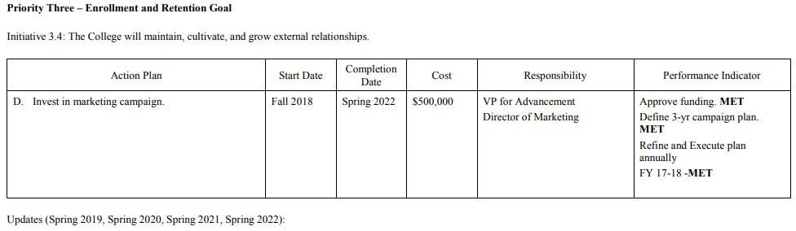

Year 1 Updates
Spring 2018:

  - December 2017, the Board of Directors approved a Transformations Capital Campaign budget of up to $1 million, of which $500,000 was specified for a marketing campaign. A line of credit was secured to finance the investments.
  - In Spring 2018, The Director of Marketing completed three-year planning for the additional marketing campaign resources.
  - In April 2018, with Year 1 expenditures to begin May-July 2018.

Year 2 Updates
Spring 2019:
  - Marketing expenses $163,675 spent in 2018-19 and drawn from Capital Campaign loan.

Year 3 Updates

Spring 2020:
- Advertising and marketing campaign through digital, billboards and limited print opportunities.
- In early 2020, Marketing engaged a new freelance digital advertising specialist to help us better target and track ads.
- Concerns raised to VP of Advancement, President, Cabinet, Development Committee, Board of Directors.

Year 4 Updates
Spring 2021:

No updates

Year 5 Updates
Spring 2022:
- Advertising and marketing campaign through digital, billboards and print opportunities.
- Hired an Enrollment Marketing Specialist to create more targeted messaging and recruitment materials. Marketing is now a three-person department.

51

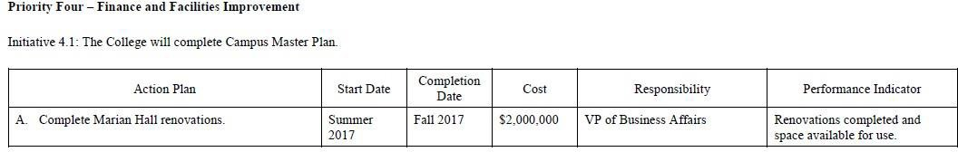

Year 1 Updates
Spring 2018:

  - Renovations completed and Marian Hall is being used by Nursing, Gateway to College, and General Education courses. New faculty and staff offices.
  - Completed without the need to acquire additional debt.
  - Grand opening held on January 25, 2018.

Year 2 Updates

Spring 2019:

  - Completed window replacement project in Marian Hall in September 2018 at total cost of
$373,713.

Year 3 Updates

Spring 2020:
- Roof was replaced in 2020.

Year 4 Updates
Spring 2021:

No update

Year 5 Updates
Spring 2022:
- Replacement of boiler

52

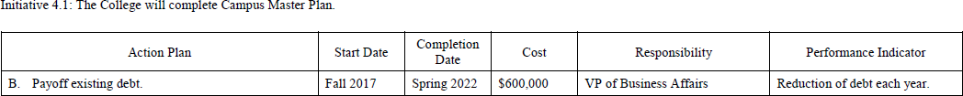

Year 1 Updates
Spring 2018:

  - Loan on Donnelly College Event Center (which opened in April 2013) was paid off.
  - Marian Hall renovations completed with no additional debt.

Year 2 Updates
Spring 2019:

  - No debt was paid off in 2018-19

Year 3 Updates

Spring 2020:

- The college continues to make monthly payments on two loans from the Archdiocese; one for capital campaign expenses and the other for new elevators in the Tower Building As of June 30, 2020, the combination of these debts was $555, 051.

Year 4 Updates
Spring 2021:

No updates

Year 5 Updates
Spring 2022:
- The college continues to make monthly payments on two loans from the Archdiocese; one for capital campaign expenses and the other for new elevators in the Tower Building As of June 30, 2022, the combination of these debts was $363,112.

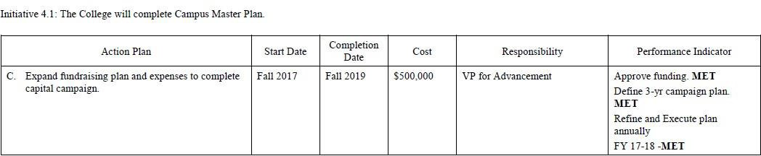

Year 1 Updates
Spring 2018:
  - In December 2017, the Board of Directors approved a Transformations Capital Campaign budget of up to $1 million, of which $500,000 was specified for fundraising expenses. A line of credit was secured to finance the investments.
  - Two new members were added to the Advancement Team in March 2018, an Advancement Officer and an Advancement Associate.
  - Revisions to Campaign Fundraising Plan were made and are ongoing, as a new Campaign Chair was named in late June.
  - Leadership gift fundraising was active in Spring 2018, with $12.6 million in requests completed

Year 2 Updates
Spring 2019:
  - Total amount spent on campaign expenses in 2018-19 was $179,209 and proceeds were drawn down on Campaign loan.

Year 3 Updates
Spring 2020:
- Completed Mabee Foundation Challenge by our October 1, 2019 deadline, securing $1 million in challenge grant funds for Phase III. To date, 79% of the funds pledged toward the Mabee Challenge have been received and 74% of the donors have paid in full. Securing the Mabee funds provided critical momentum for campaign fundraising and enabled Phase III construction to proceed as scheduled.
- As of June 30, 2020, we had raised $33,911,055, or 95% of our total project need of $34.2 million. See evidence for June 30,2020 campaign fundraising progress report.

Year 4 Updates
Spring 2021:
No updates

Year 5 Updates
Spring 2022:

- As of June 30, 2022, we have raised $34,821,755 exceeding our total project need of $34.2 million. See evidence for June 30,2022 campaign fundraising progress report.

54

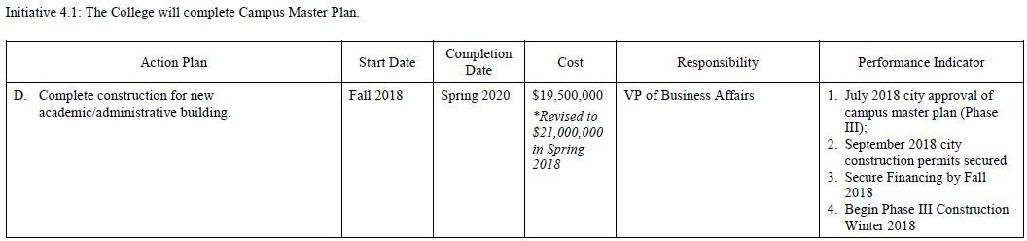

Year 1 Updates
Spring 2018:

  - Decisions in spring to incorporate a 2-story, rather than flat parking lot, into the Campus Master Plan’s Phase III scope raised the estimated project cost to $21,000,000.
  - In late May 2018, Donnelly’s Architect (Burns & McDonnell) and Owner’s Representative for the Campus Master Plan/Building Project (MC Realty) submitted detailed Phase III plans to the Unified Government (UG) of Wyandotte County for city approval of the plans.
  - As of June 2018, UG staff reported they will be recommending the plan for city approval, expected by late July 2018.

Year 2 Updates
Spring 2019:

  - In Progress

Year 3 Updates
Spring 2020:

- Parking garage is completed.

Year 4 Updates
Spring 2021:

No updates

Year 5 Updates
Spring 2022:

No updates

55

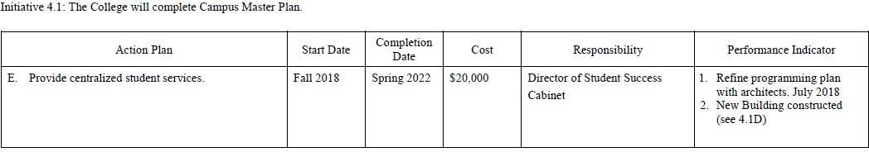

Year 1 Updates
Spring 2018:

  - To achieve immediate benefits from centralizing student services as planned in the new academic building, the first three floors of the existing tower building were entirely reconfigured in Spring 2018, bringing all core student services to the first floor, and connecting the Academic Support Center (ASC), including the Library and Tutoring Services) between the first floor and lower level.
  - By piloting the centralization of student services in our existing facilities, it is hoped valuable lessons learned can be applied to the design and execution of the new building.
  - Re-branding efforts are planned to be complete by Fall 2018, along with new supplies/furnishings for the ASC made possible through Donnelly’s USDE Title V grant.
Year 2 Updates
Spring 2019:

  - In summer, 2018, all administrative offices were moved off the first floor. The lower level and the
first floor now house the Academic Support Center, Admissions, Advising, Registrar, Business Office, Financial Aid, Library, and Student Life.

Year 3 Updates
Spring 2020:
- The Campus Master Plan is progressing with the new academic building set to open in August 2020. The student’s services spaces have been designed for students to access all support services on the first floor (Academic Resource Center on the 2nd floor).

Year 4 Updates
Spring 2021:
- The first year in the new building proved successful in our attempt to centralize student services. Students can navigate the enrollment process with admissions, testing, financial aid, and advising in one area.

Year 5 Updates
Spring 2022:
Met

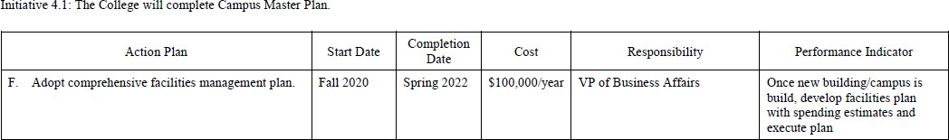

Year 1 Updates
Spring 2018:

  - Not started

Year 2 Updates
Spring 2019:

  - Planned upon completion of new building in 2020.

Year 3 Updates
Spring 2020:

- Not started.

Year 4 Updates
Spring 2021:

No updates

Year 5 Updates
Spring 2022:

- In July 2021 Lisa Stoothoff was appointed as Donnelly’s first Chief Operating Officer, with one of her responsibilities being maintaining the building and grounds.
- In July 2021, Donnelly College hired M.C. Realty as the management company, providing us with a property management system, a facilities manager, and a weekly inspection by an engineer to campus.

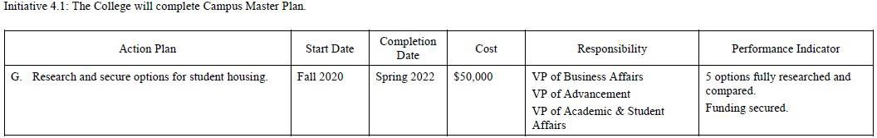

Year 1 Updates
Spring 2018:

  - Not started

Year 2 Updates
Spring 2019:

  - Not started

Year 3 Updates
Spring 2020:

  - Not started

Year 4 Updates
Spring 2021:

No updates

Year 5 Updates
Spring 2022:

- Cabinet made the decision to tear down the church property across the street from campus as a possible location for future housing.

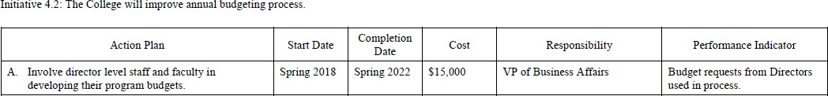

Year 1 Updates
Spring 2018:
  - Each department director was provided budget request forms including the previous year actual and current year budget numbers and submitted their requests for the 2018-19 fiscal year budget. When the final budget was approved, feedback was provided, and directors were allowed to adjust the line items within their approved budget amounts.
  - New Budget Process Policy developed and approved by Board of Directors in May 2018.
Year 2 Updates
Spring 2019:
  - Established Budget Committee of representatives of various divisions to review budget requests from Directors to allocate resources.
Year 3 Updates
Spring 2020:
- Each department director was provided with a 2020- 2021 budget form, including the previous year's budget.
- They were given instructions to align their budget requests with the Strategic Plan, Assessment of Student Learning Outcomes, and mission of the College.
- Each director met with the Vice President of Business Affairs and the Vice President of Academic and Student Affairs to justify budget requests and check for redundancies.
- Each budget was reviewed. The VP of Business and the VPASA made operational budget decisions that align with the College.
- The April 29, 2020, Board of Directors meeting was postponed until June 3, 2020 due to COVID-19. Once the budget is reviewed and voted on by the Board, the VP of Business Affairs and the VPASA will meet with each program director and present them with their final budget for the fiscal year.
Year 4 Updates
Spring 2021:
- Each department director was provided with a 2020- 2021 budget form; including the previous year's budget.
- They were given instructions to align their budget requests with the Strategic Plan, Assessment of Student Learning Outcomes, and mission of the College.
- Each director met with the Vice President of Business Affairs and the Vice President of Academic and Student Affairs to justify budget requests and check for redundancies.
- Each budget was reviewed. The VP of Business and the VPASA made operational budget decisions that align with the College.
- At the he May 5, 2021, Board of Directors meeting, the budget was approved. The CFO and VPASA met with each program director and presented them with their final budget for the fiscal year.
* However, during the summer, because of changing circumstances, the budget was revised during summer 2021 and will be represented for board approval on September 1 board meeting.
Year 5 Updates
Spring 2022:
- No updates

59

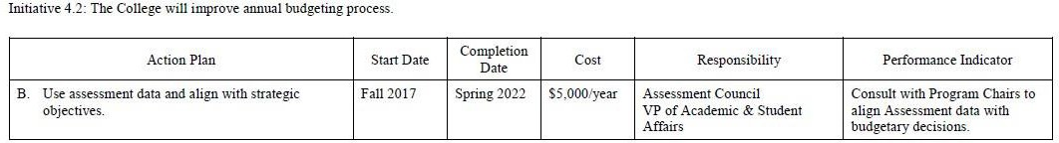

Year 1 Updates
Spring 2018:
  - Assessment line item added to budgeting forms for all departments.
  - 2019-20 preparatory budget meetings scheduled in 2018-19.

Year 2 Updates
Spring 2019:
  - All Program Directors align department budgets per the strategic plan. Directors must align variable expenses with current SP in order to be approved for funding.

Year 3 Updates

Spring 2020:
- The Director of Institutional Research met 1:1 with all Program Directors to review their Assessment Plans.
- The VP of Business Affairs and the VP of Academic and Student Affairs also met with each Program Director to align budget requests with Assessment Plans.
- The VP of Academic and Student Affairs met with each Program Director to review Assessment Plans.
- The Assessment Academy Team will review the timeline process for Assessment Plans at the 6/2020 meeting.

Year 4 Updates
Spring 2021:
- In addition to Year 3 new initiatives, Program Directors were asked to allocated resources in alignment of the mission and prioritize spending while reviewing processes for assessment of student learning within its operational budgets.
Examples:
Nursing: 2.1 C to increase ADON Salary for retention of staff 3.4 B to have Student Nurse Association work in the community to foster relationships and provide education to community groups
Success first: 1.2 D to promote service-learning projects 2.2 focus on faculty and staff development3.3 to increase persistence among students
Institutional Effectiveness: 1.2 A VIA Export Enhancement for assessment data tracking2.4 B Course Evaluation in Learning Management System for data tracking 1.2 A CCSSE Survey of Student Engagement
Year 5 Updates
Spring 2022:
Program Directors were asked to allocated resources in alignment of the mission and prioritize spending while reviewing processes for assessment of student learning within its operational budgets.
Examples:
- Admissions: Purchase and implementation of Common App to increase scope of Admissions and ease of applications
- Academic and Student Affairs: Purchase of Cascade Software to allow for a dashboard update of Strategic Planning Initiatives
- Office of Mission: Using funds to increase Catholic Identity on campus.
- LAS: Increase full time faculty by 2 to improve student classroom experience.

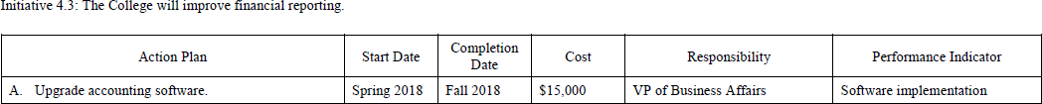

Year 1 Updates
Spring 2018:

  - Began strategy for securing grant funding for this initiative.

Year 2 Updates
Spring 2019:

  - Upgrade installed in March 2019.

Year 3 Updates:
Spring, 2020

- New personnel are being trained on the software.

Year 4 Updates
Spring 2021:
- The accounting software was updated in spring 2021 and new personnel were trained on the software.

Year 5 Updates
Spring 2022:

- Continued training on existing software which streamlined processes and saved labor hours

61

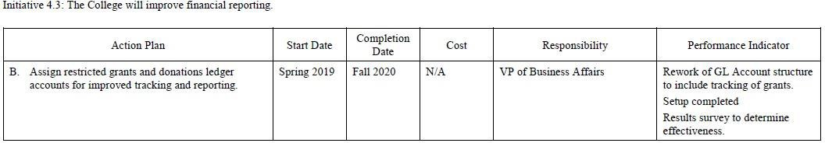

Year 1 Updates
Spring 2018:

  - Not started

Year 2 Updates
Spring 2019:

  - Not started

Year 3 Updates
Spring, 2020:
- Grant funds from the Westermann Foundation were requested to purchase an upgrade to the accounting system that would make this kind of tracking possible-- (see evidence of 2018 proposal).

- The funds were allocated to this purpose at the end of 2019.

Year 4 Updates
Spring 2021:
- New ledger accounts were added to account for the CARES Act, HEERF II, HEERF III, MIP and FIPSE grants.

Year 5 Updates
Spring 2022:
- The CFO and the Advancement Department worked to better align pledges in advancement reports with the general ledger accounts.

62

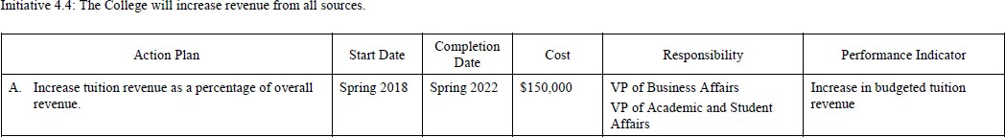

Year 1 Updates
Spring 2018:
  - Tuition revenue in the 2018-19 Budget increased by 3% over the 2017-18 Budget.

Year 2 Updates
Spring 2019:
  - Tuition revenues for 2019-20 are 60% of approved budget compared to 53% in 2018-19.

Year 3 Updates
Spring, 2020:
- Tuition was increased by 3% for the next fiscal year.
- Advancement worked with the VPASA and faculty to secure two federal grants:
In September 2019, Donnelly was awarded a five-year, $3 million Title V Developing Hispanic-Serving Institutions grant to improve our bachelor’s programs and nursing programs, and In April 2020 Donnelly was selected to participate in the Second Chance Pell federal pilot program—allowing our Lansing Correctional students to access federal Pell grants. Both efforts were designed to build academic program capacity and student aid assistance to help increase those program enrollments and overall tuition revenue.

Year 4 Updates
Spring 2021:
- The Donnelly budget is on a cash basis. On the revenue side, tuition was increased by 7.5% for the next fiscal year. A new nursing cohort is being added, which will bring in more tuition revenue. Also, revenue will increase because of Employee Retention credits and Forgiveness of the Payroll Protection Plan Loans. The college realizes that these monies will not be available in the 2022-23 fiscal year and will be making plans to adjust the budget for these lost revenues.

Year 5 Updates
Spring 2022:
- Increased tuition by 7.5% and increased some nursing training course offerings

 | Initiative 4.4: The College will increase revenue from all sources.
 | 4.4 B. Reduce dependence on annual fund for operating budget by 10% annually (offset by increase in tuition and investment revenue). | Fall 2017 | Spring 2022 | N/A | VP of Business Affairs  VP of Advancement | Reduction of 10% in annual fund contributions.
 |  |  |  |  | VP of Academic and Student Affairs

Year 1 Updates
Spring 2018:
  - The 2018-19 DC Operational Budget decreased Annual Fund dependence by 7% from the 2017-18 Annual Fund Budget.

Year 2 Updates
Spring 2019:
  - Gifts, grants, and annual fund revenue for 2019-20 is 37% of approved budget compared to 38% in 2018-19.
  - Did not meet plan due to discontinued academic program in Spring 2019.

Year 3 Updates
Spring 2020:
- Although there was not a budgeted reduction in Year 3’s 2019-20 Operating Budget, there is a 10% reduction budgeted for the 2020-21 DC Operating Budget (the 4th year of the strategic plan).

Year 4 Updates
Spring 2021:
- Cash outlays for Debt Service, Bad Debt Expense were added to the budget. Also, because of the NMTC setup, Donnelly now must now pay lease payments to the subsidiary, Donnelly College Real Estate Holdings. There was also a substantial increase in the marketing budget. This budget used to be paid by the Capital Campaign loan from the archdiocese. Now that the campaign is ending, these expenses are reflected on the Donnelly budget.

Year 5 Updates
Spring 2022:
- Annual fund as a percentage of revenues decreased by 2%

64

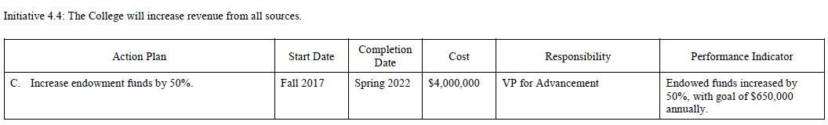

Year 1 Updates
Spring 2018:
  - During the 2017-18 fiscal year, a total of $172,353 was added to Donnelly endowments: $109,353 from donors and $63,000 from Donnelly’s USDE Title V grant matching funds.

Year 2 Updates
Spring 2019:
  - Added $143,995 to endowments funds in 2018-19.

Year 3 Updates
Spring, 2020:
- Investment funds (restricted and unrestricted) as of June 30, 2017 totaled $7,816,230.
The 2018-19 audit was completed in 19-20, and the audited invested funds total for 2018- 19 of $8,636,692, a 10.5% increase in the first two years of the current strategic plan.
- In 2019-20, $65,265 of donor funds were contributed to investment funds, as well as
$25,000 in matching funds from the U.S. Department of Ed Title V grant, for a total of
$90,000 in new contributions, leading to 12% increase over 2017 balance. As a significant help to future fundraising, the 5-year Title V grant secured in Sept 2019 included $600,000 in endowment donor matching funds. $575,000 in matching funds remaining as of June 30,2020.

Year 4 Updates
Spring 2021:
No updates
Year 5 Updates
Spring 2022:
- Investment funds (restricted and unrestricted) as of June 30, 2017 totaled $7,816,230. The 2020-21 audit shows an invested funds total for 2020-2021 of $11,502,585 which represents a 32% increase in the first four years of the current strategic plan.
- In 2021-22, $167,853 of donor gifts were contributed to investment funds, as well as $167,853 in matching funds from the U.S. Department of Ed Title V grant, for a total of $335,706 in new contributions. As a significant help to future fundraising, the 5-year Title V grant secured in Sept 2019 included $600,000 in endowment donor matching funds. There are $303,147 in matching funds remaining as of June 30,2022.
- Donnelly’s efforts to begin a 2022-2025 Strategic plan began in 2020 and continued throughout 2021 and early 2022. It was clear from the beginning in 2020 that Donnelly’s Board of Directors and college
leadership would want an endowment campaign as a key component of the college’s upcoming strategic priorities.
- As a part of the new strategic planning process in FY 21-22, the VP of Advancement developed a working outline of an Endowment Campaign Plan. It was vetted and discussed in a break-out group of the Board at its December 1, 2021 meeting. The plan was also discussed, expanded and vetted as a part of Strategic Planning Council in the spring semester 2022. The strategic plan framework approved by the Board of Directors at the May 4, 2022 meeting did include endowment campaign objectives in line with the Advancement Department’s more detailed plans. Evidence – endowment campaign planning document.

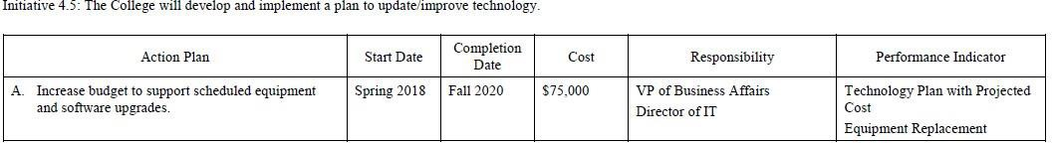

Year 1 Updates
Spring 2018:

  - This plan was delayed until Fall 2018 as the technology plan was not developed prior to the 2018-19 budget and other IT projects were implemented in 2017-18.
  - In addition to the IT-related projects listed below in 4.5.B, the IT division also updated IT inventory and tracking procedures and provided critical IT support and for the Summer 2018 campus reorganization of offices across three floors within the main 8-story academic building.

Year 2 Updates
Spring 2019:

  - Purchased new equipment with specific grant request.
Year 3 Updates
Spring 2020:

- Updated software and system security with specific grants.

Year 4 Updates
Spring 2021:

None

Year 5 Updates
Spring 2022:
- Continued efforts from 2021. Upgraded Empower and GP Dynamics.

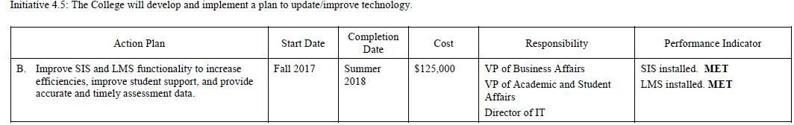

Year 1 Updates
Spring 2018:

  - Fall 2017: Conversion to new SIS system (Empower) completed in December 2017 and progress toward full integration will be complete in Summer 2018 for financial aid and online forms, etc. The cost of implementation and the first-year site license was $100,481 and was partially funded by a grant of $19,500 from H&R Block Foundation.
  - Summer 2018: Conversion to new LMS system (Canvas) completed in June 2018 with full implementation for the Fall 2018 semester. The cost of implementation was $18,500 and first-year support cost of $2,911.
  - Summer 2018: New system (Watermark) that provides connection between the SIS and LMS system will be implemented over the Summer to assist with assessment data collection. This system was not in the plan originally but was deemed by administration to be crucial for providing assessment data. The cost of the site license was $25,500 for the first year and was funded through a grant from the H&R Block Foundation.

Year 2 Updates
Spring 2019:

  - Completed

Year 3 Updates
Spring 2020:

No updates

Year 4 Updates
Spring 2021:

No updates

Year 5 Updates
Spring 2022:
- Provided extensive training on Empower for all users: Admissions, Student Advising, Financial Aid, Billing, Registrar and Business Office

