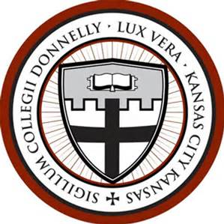
Professional Development Fund Use

Created: June 2020
Approved by: VPASA
Approved by Administrative Council:
Responsible Official: HR
Donnelly’s Professional Development Program is intended to enable faculty, staff and administrators to better serve students by increasing knowledge and skills and to progress professionally in individual disciplines. The program also seeks to foster an atmosphere wherein learning is valued and shared among colleagues. Donnelly College will provide resources necessary to support a commitment to ongoing professional development.

The Professional Development Fund is money the College has reserved for the professional development of staff and faculty. Available funds are based on budget approval.

- Courses to prepare for a licensing exam in a professional field
- Coursework to complete a degree or certificate in a related field.
- Participation in a conference, course, or training to develop skills in one area necessary for successful employment, or expansion of employment. Conference fees, travel and lodging included.
- Attendance in a program to increase computer or business skills
- Language study to enhance employability or workplace communication
- Certification or Licensure fees
- Association membership to an organization in related field.
- Books or training materials associated with an approved activity
- Tuition Reimbursement for a course in a related field (must receive a grade of “B” or higher and submit current transcripts.)

